catalogue
一 Product introduction 6
1.1 Factory Default 6
1.2 Obtain device information 6
二 Wireless settings 7
2.1 Pairing setup code 7
2.2 BLE BLUETOOTH MODE 7
2.3 Mode Selection 7
2.4 Set the upload data speed delay 8
2.5 Check software version 8
2.6 Set sleep time 9
2.7 USB KBW 9
2.8 USB COM keyboard 9
2.9 Output format 10
2.10 Output forced letter case conversion 11
三、Scanning module settings 12
1.2 Enable/Disable All Symbologies 12
1.3 Video Reverse 12
1.3.1 Trigger Mode 13
1.3.2 Decode Session Timeout 14
1.4 Continuous Mode 15
1.4.1 Mode Entry 15
1.4.2 Decode Session Timeout 15
1.4.3 Timeout Between Decodes 16
1.4.4 Enable/Disable Timeout Between Decodes (Same Barcode) 17
1.4.5 Timeout Between Decodes (Same Barcode) 17
1.5 Sense Mode 18
1.5.1 Mode Entry 18
1.5.2 Sensitivity 18
1.5.3 Image Stabilization Timeout 19
1.5.4 Decode Session Timeout 20
1.5.5 Sense Waiting Timeout 21
1.5.6 Enable/Disable Timeout between Decodes (Same Barcode) 22
1.5.7 Timeout Between Decodes (Same Barcode) 22
1.6 Command Triggering Mode 23
1.6.1 Mode Entry 23
1.6.2 Decode Session Timeout 24
2 Illumination & Aiming 24
2.1 Illumination 24
2.2 External Illumination 25
2.3 Aiming 26
3 Beep & LED Notifications 27
3.1 Buzzer 27
3.1.1 Passive Buzzer 27
3.1.2 Active Buzzer 27
3.2 All Beep 28
3.3 Startup Beep 28
3.4 Good Read Beep 29
3.4.1 Good Read Beep for Setting Barcode 29
3.4.2 Good Read Beep for Non-setting Barcode 30
3.4.3 Good Read Beep Timeout 30
3.5 Startup LED 31
3.5.1 Enable/Disable Startup LED 31
3.5.2 Startup LED Timeout 31
3.6 Good Read LED 32
3.6.1 Enable/Disable Good Read LED 32
3.6.2 Good Read LED Timeout 33
3.7 Good Read Vibration 33
3.7.1 Enable/Disable Good Read Vibration 33
3.7.2 Good Read Vibration Timeout 34
3.8 Read Fail Message 35
3.8.1 Transmit RF Message 35
3.8.2 Edit RF Message 35
4 Date Editing 36
4.1 Custom Prefix 36
4.2 AIM ID Prefix 38
4.3 Code ID Prefix 38
4.4 Data Segment Truncation 43
4.5 Custom Suffix 45
4.6 Tail Suffix 46
4.7 Transmit Protocol 47
4.8 HID KBW Output Compatibility 48
5 Symbologies 48
5.1 Enable/Disable All Symbologies 48
5.2 Video Reverse 49
5.3 EAN-13 50
5.3.1 Enable/Disable EAN-13 50
5.3.2 EAN-13 Transmit Check Digit 50
5.3.3 EAN-13 Add-On Code 51
5.3.4 EAN-13 Add-On Code Required 51
5.4 ISSN 52
5.4.1 Enable/Disable ISSN 52
5.4.2 ISSN Add-On Code 52
5.4.3 ISSN Add-On Code Required 53
5.5 ISBN 53
5.5.1 Enable/Disable ISBN 53
5.5.2 ISBN Add-On Code 53
5.5.3 ISBN Add-On Code Required 54
5.6 EAN-8 54
5.6.1 Enable/Disable EAN-8 54
5.6.2 EAN-8 Transmit Check Digit 55
5.6.3 EAN-8 Add-On Code 55
5.6.4 EAN-8 Add-On Code Required 56
5.6.5 EAN-8 to EAN-13 56
5.7 UPC-A 57
5.7.1 Enable/Disable UPC-A 57
5.7.2 UPC-A Transmit Check Digit 57
5.7.3 UPC-A Add-On Code 57
5.7.4 UPC-A Add-On Code Required 58
5.7.5 UPC-A to EAN-13 59
5.8 UPC-E 59
5.8.1 Enable/Disable UPC-E 59
5.8.2 UPC-E Transmit Check Digit 59
5.8.3 UPC-E Add-On Code 60
5.8.4 UPC-E Add-On Code Required 60
5.8.5 UPC-E to UPC-A 61
5.9 Code128 61
5.9.1 Enable/Disable Code128 61
5.9.2 Set Length for Code 128 62
5.10 Code39 62
5.10.1 Enable/Disable Code39 62
5.10.2 Set Length for Code39 63
5.10.3 Code39 Check Digit Verification (Modulo 43) 63
5.10.4 Code39 Transmit Start/Stop Character 64
5.10.5 Enable/Disable Code39 Full ASCII 65
5.11 Code32 65
5.11.1 Enable/Disable Code32 65
5.11.2 Code32 Transmit Check Digit 66
5.11.3 Code32 Transmit Start/Stop Character 66
5.11.4 Code32 Transmit Prefix Character 67
5.12 Code93 67
5.12.1 Enable/Disable Code93 67
5.12.2 Set Length for Code 93 67
5.12.3 Code93 Check Digit Verification 68
5.13 CodaBar 69
5.13.1 Enable/Disable CodaBar 69
5.13.2 Set Length for Codabar 69
5.13.3 CodaBar Check Digit Verification (Mod-16) 70
5.13.4 CodaBar Transmit Start/Stop Character 71
5.14 Interleaved 2 of 5 72
5.14.1 Enable/Disable Interleaved 2 of 5 72
5.14.2 Set Length for Interleaved 2 of 5 72
5.14.3 Interleaved 2 of 5 Check Digit Verification (Mod-10) 73
5.15 ITF-14 74
5.15.1 Enable/Disable ITF-14 74
5.16 ITF-6 74
5.16.1 Enable/Disable ITF-6 75
5.17 Industrial 2 of 5 75
5.17.1 Enable/Disable Industrial 2 of 5 75
5.17.2 Set Length for Industrial 2 of 5 75
5.17.3 Industrial 2 of 5 Check Digit Verification (Mod-10) 76
5.18 Matrix 2 of 5 77
5.18.1 Enable/Disable Matrix 2 of 5 77
5.18.2 Set Length for Matrix 2 of 5 77
5.18.3 Matrix 2 of 5 Check Digit Verification (Mod-10) 78
5.19 Code11 79
5.19.1 Enable/Disable Code11 79
5.19.2 Set Length for Code 11 79
5.19.3 Code11 Check Digit Verification 80
5.19.4 Code11 Transmit Check Digit 80
5.20 MSI-Plessey 81
5.20.1 Enable/Disable MSI-Plessey 81
5.20.2 Set Length for MSI-Plessey 81
5.20.3 MSI-Plessey Check Digit Verification 82
5.20.4 MSI-Plessey Transmit Check Digit 82
5.21 GS1-Databar (RSS) 83
5.21.1 Enable/Disable RSS-14 83
5.21.2 Enable/Disable RSS-Limited 83
5.21.3 Enable/Disable RSS-Expanded 84
5.21.4 Set Length for RSS 85
5.22 Micro QR Code 85
5.22.1 Enable/Disable Micro QR Code 85
5.23 QR Code 86
5.23.1 Enable/Disable QR Code 86
5.24 Data Matrix 86
5.24.1 Enable/Disable DM 86
5.25 PDF417 87
5.25.1 Enable/Disable PDF417 87
5.26 Micro PDF417 87
5.26.1 Enable/Disable Micro PDF417 87
5.27 Aztec Code 88
5.27.1 Enable/Disable Aztec Code 88
5.28 Maxi Code 88
5.28.1 Enable/Disable Maxi Code 88
6 Appendix C：Code ID Table 89
7 Appendix D：ASCII Table 90
8 Appendix E：Digit Barcodes 93
9 Appendix F：Save/Cancel Barcodes 95

Product introduction

Factory Default
Terminator：Enter(\r)。
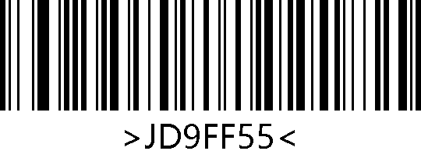
Factory Default

Obtain device information
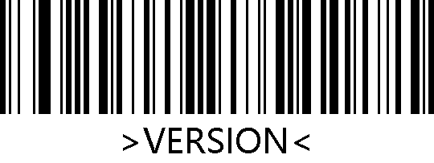
product version number

Wireless settings

Pairing setup code
①Pair the receiver: Scan the following two barcodes in sequence.And connect the receiver to computer；

2.4G MODE Connecting devices

②Pair Bluetooth devices in HID mode: Scan the following two barcodes in sequence, turn on the Bluetooth device to search for RB_Scanner_HID connection.

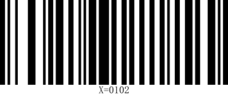
HID MODE Connect

BLE BLUETOOTH MODE
Pairing Bluetooth devices: Scan the following two barcodes in sequence, and perform Bluetooth search RB_Scanner_BLE on the software that supports BLE
Connect.Note: BLE mode needs to be output on specific software (Bluetooth serial port)
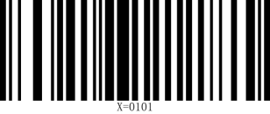
BLE MODE Connect

Mode Selection
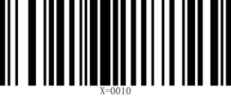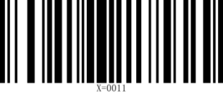
Instant upload mode Inventory Mode


Over-the-distance storage mode

①Operations in Inventory Mode

Upload all data Upload new data (that is, data that has not been uploaded before)

Display saved data Showing unuploaded data

Clear all data

Set the upload data speed delay
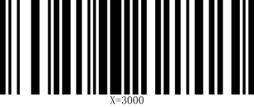
No delay Delay 10ms

Delay 20ms

Check software version
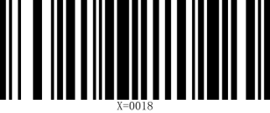
Check the scanner software version Check the receiving end version number

Set sleep time
X=1yyy(x=1000 means no sleep, sleep time calculation formula: yyy*10=z seconds)
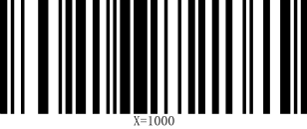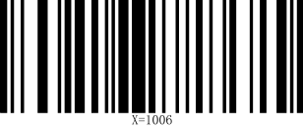
No sleep 60 seconds

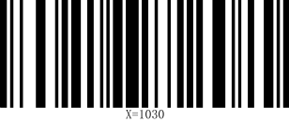
120 seconds 5 minutes

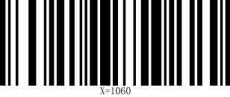
10 minutes

USB KBW
When the scanner is connected to the host using a USB receiver, the scanner can be configured as a standard keyboard input by scanning the USB KBW setup code.
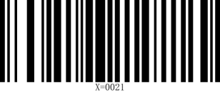
USB KBW keyboard

USB COM keyboard
When the scanner is connected to the host using a USB receiver, the receiver virtual serial port output mode can be changed by scanning the USB COM setup code.

USB COM

Output format
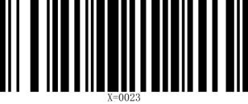
UTF-8 GBK

When the scanner recognizes it as a keyboard input device, different countries have different input characters, so you need to set different national languages. The keyboard defaults to the US language.
2.10 multi-language keyboards
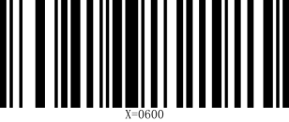U.S. (default) 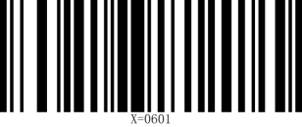Belgium (French)

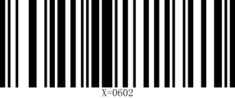Brazil (Portuguese)  Canada

Czech Republic  Denmark

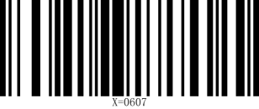Finland France

Germany Italy

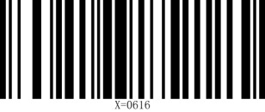Portugal Spain

Türkiye-F Türkiye-Q

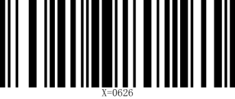U.K. 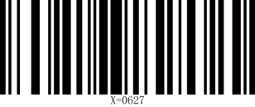 Japan

Russia Vietnamese

Output forced letter case conversion
Letter conversion, when outputting barcodes with letter content, you can configure the output result to be all uppercase or all lowercase. For example, if the barcode content is: ab123dE, if you scan the "Convert to uppercase" barcode, the output result is: AB123DE; if you scan the "Convert to lowercase" barcode, the output result is: abc123de; the default case is not converted.

Do not convert Uppercase

Lowercase Case conversion

三、Scanning module settings

Enable/Disable All Symbologies
Scanning the following setting barcodes will enable or disable symbologies. If disable all symbologies, only the setting barcodes can be read.

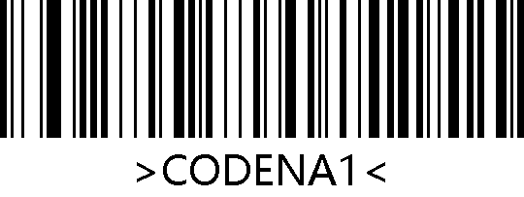
Enable All Symbologies
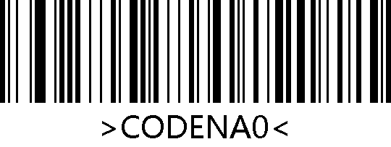
Disable All Symbologies
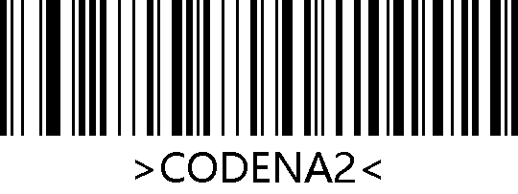
* Enable Default Symbologies

Video Reverse
In some special scenarios, the following barcodes can configure the engine to read regular and inverse barcodes. If enabled, it will affect the scanning speed. Please enable it in the desired scenario.

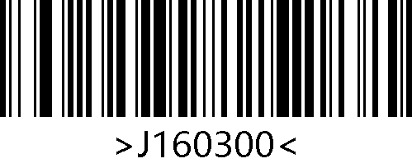
*1D Regular Symbologies
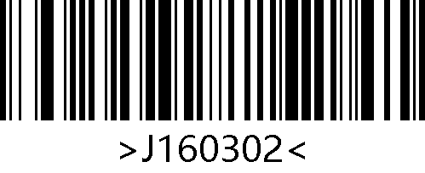
1D Regular and Inverse Symbologies
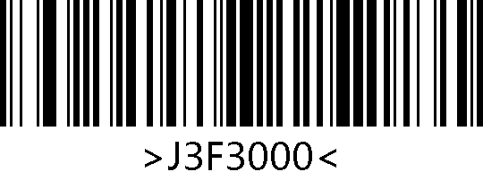
* Regular QR
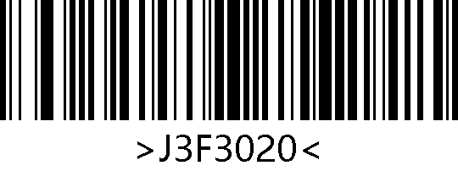
Regular and Inverse QR
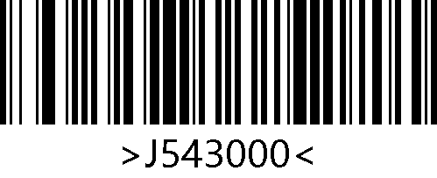
* Regular DM
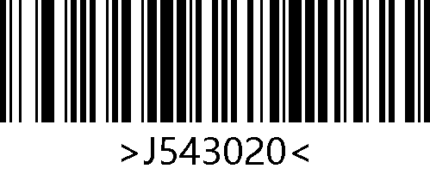
Regular and Inverse DM

Trigger Mode
The manual mode can be configured to edge or level trigger by scanning the following barcodes.

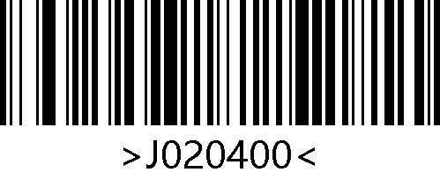
*Level Trigger
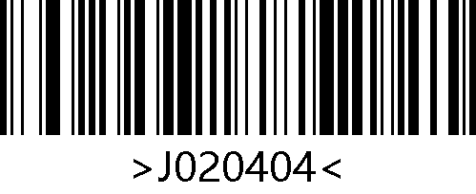
Edge Trigger

Decode Session Timeout
In manual mode, this parameter refers to the maximum duration the decode session continues before good read. The range of decode session timeout is 0.1~25.5 seconds, with a step size of 0.1 seconds. When set to 0, it indicates an infinite reading time. The default duration is 5.0 seconds.

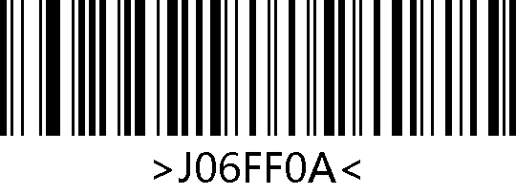
1000ms
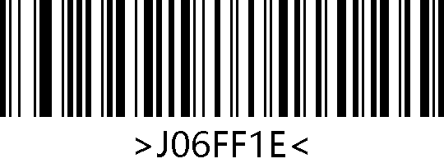
3000ms
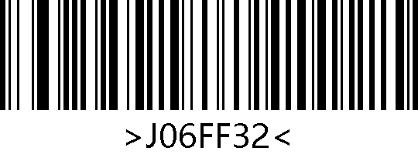
*5000ms
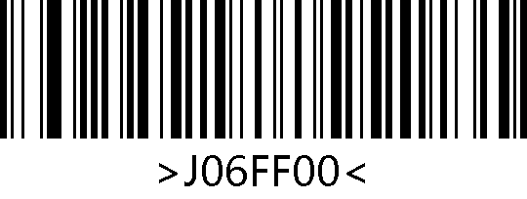
Infinite Duration

Continuous Mode

Mode Entry
After setting up, the engine immediately starts reading barcodes without trigger. When good read and outputs data or the decode session timeout expires, the engine will automatically start the next reading after waiting for a certain period of time (configurable). If the following situations do not occur, the engine will cycle operating in the above way: during the reading process, the user can also manually pause the reading by clicking the trigger button, and click the trigger button again to allow the engine to continue to cycle the reading.

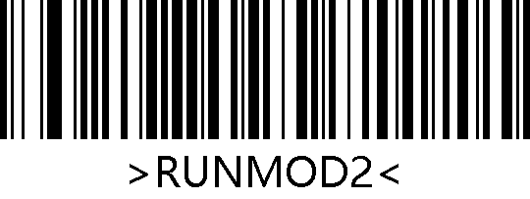
Continuous mode

Decode Session Timeout
In continuous mode, this parameter refers to the maximum duration the decode session continues before good read. After good read or the decode session timeout expires, the scan engine will enter the interval period of not capturing and reading. The range of decode session timeout is 0.1~25.5 seconds, with a step size of 0.1 seconds; When set to 0, it indicates an infinite reading time. The default duration is 5.0 seconds.

1000ms
3000ms
*5000ms
Infinite Duration

Timeout Between Decodes
This parameter refers to the timeout between decode sessions, when a decode session ends, next session will not happen until the timeout between decodes expires. The setting range of timeout between decode is 0-25.5 seconds, with a step size of 0.1 seconds. The default interval duration is 1.0 seconds.

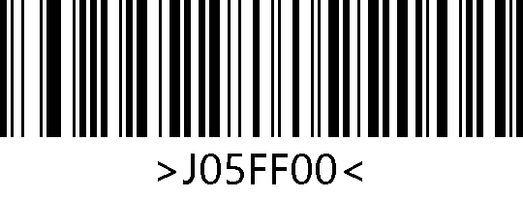
No Interval
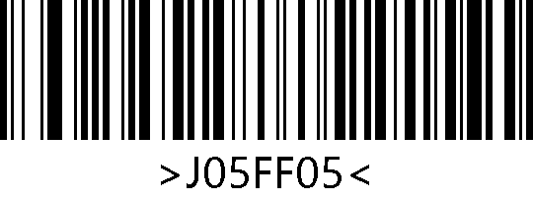
500ms
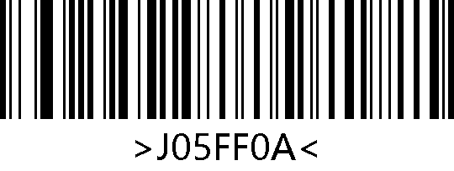
*1000ms
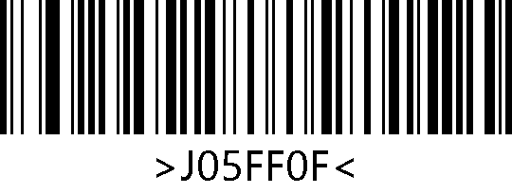
1500ms
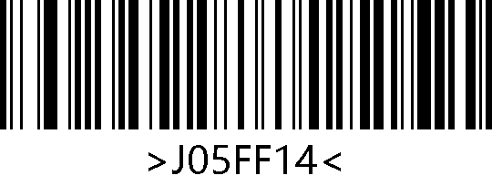
2000ms

Enable/Disable Timeout Between Decodes (Same Barcode)
Timeout between decodes (same barcode) can avoid undesired rereading of same barcode in a given period of time. The engine is only allowed to re-read same barcode after the timeout between decodes (same barcode) expires.

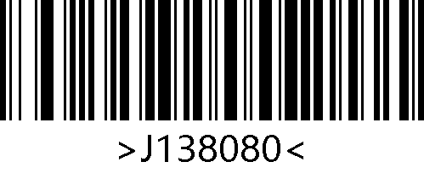
Enable Timeout Between Decodes
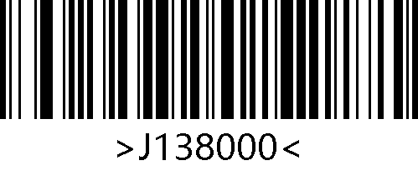
*Disable Timeout between Decodes

Timeout Between Decodes (Same Barcode)
When the timeout between decodes (same barcode) is enabled, the following setting barcodes can set the timeout between decodes for same barcode.

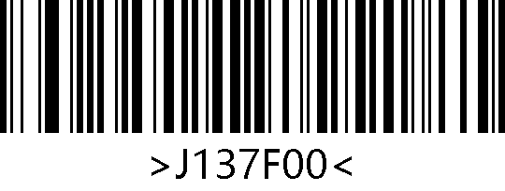
Infinite Delay
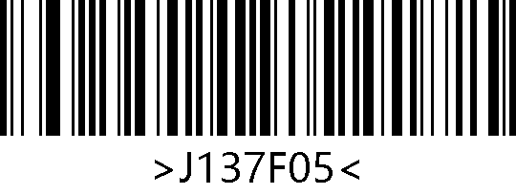
500ms

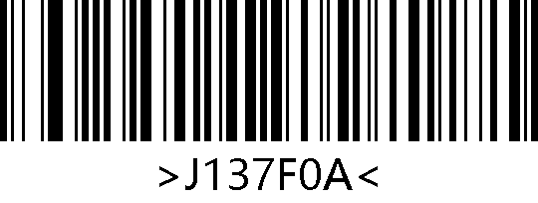
*1000ms
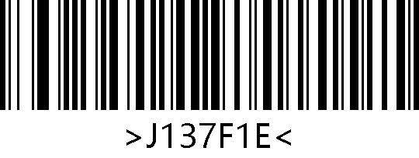
3000ms
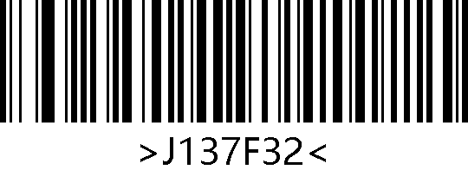
5000ms

Sense Mode

Mode Entry
After setting up, the engine immediately starts monitoring the surrounding ambient illumination without trigger. When the scene changes, the engine starts reading until the image stabilization timeout expires. If the following situation does not occur, the engine will cycle operating in the above way: if the engine fails to scan the barcode within a decode session timeout, it will automatically pause reading and enter the monitoring mode. In sense mode, the scan engine can also start reading after the user presses the trigger button, and continue monitoring after good read and output data or when the user releases the trigger button.

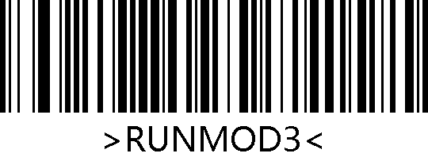
Sense Mode

Sensitivity
Sensitivity refers to the degree of acuteness of the engine’s response to changes in ambient illumination in sense mode. When the engine judges that the degree of changes meets the requirements, it will switch from monitoring mode to scanning mode.

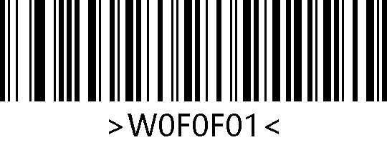
Low
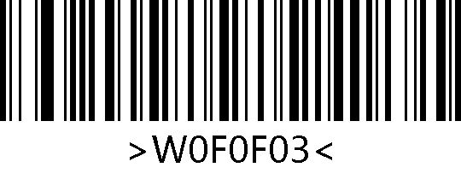
Medium
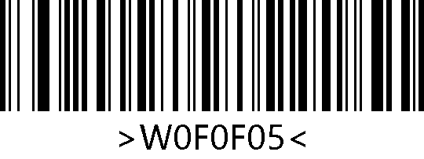
*High
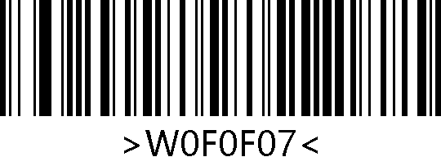
Enhanced

Image Stabilization Timeout
Image Stabilization Timeout refers to the time that the engine needs to wait for the image to stabilize between detecting scene changes and starting to read barcodes in sense mode. The range of image stabilization timeout is 0-25.5 seconds, with a step size of 0.1 seconds. The default image stabilization timeout is 0 seconds.

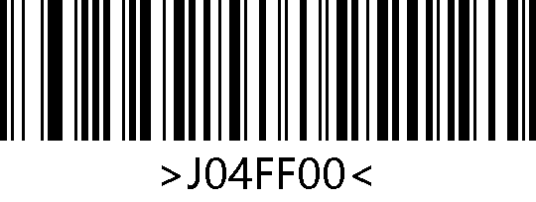
*0ms
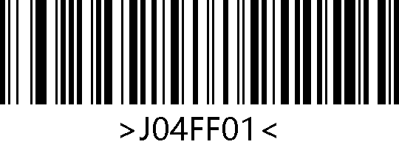
100ms
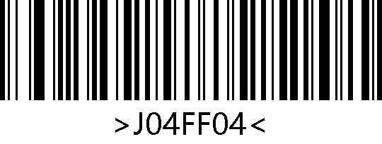
400ms
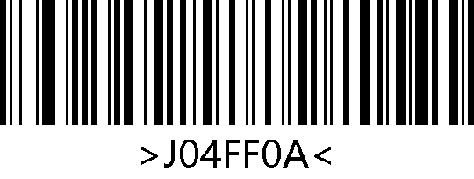
1000ms
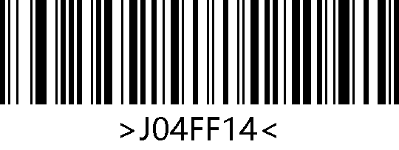
2000ms

Decode Session Timeout
In sense mode, this parameter refers to the maximum duration the decode session continues before good read. After good read or the decode session timeout expires, the scan engine will enter the interval period of not capturing and reading. The range of decode session timeout is 0.1~25.5 seconds, with a step size of 0.1 seconds. When set to 0, it indicates an infinite reading time. The default duration is 5.0 seconds.

1000ms
3000ms
*5000ms
Infinite Duration

Sense Waiting Timeout
Sense waiting timeout refers to the time that the engine needs to wait for re sense after good read or the decode session timeout expires in sense mode. The setting range for sense waiting timeout is 0-25.5 seconds, with a step size of 0.1 seconds. The default duration is 0 seconds.

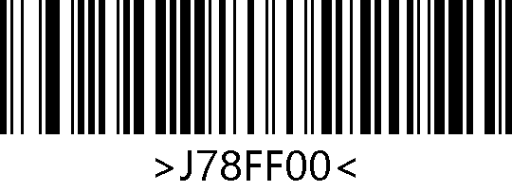
*0ms
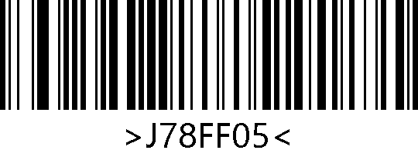
500ms
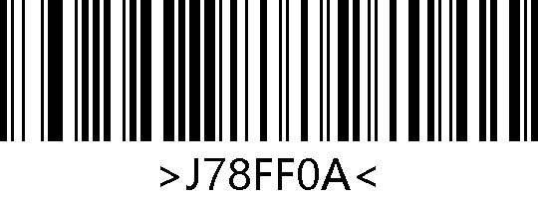
1000ms
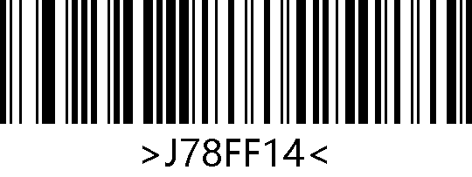
2000ms
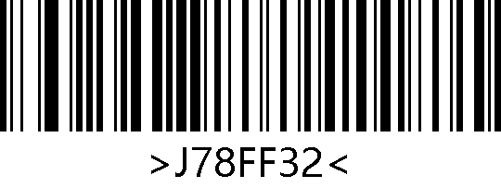
5000ms

Enable/Disable Timeout between Decodes (Same Barcode)
Timeout between Decodes (Same Barcode) can avoid undesired rereading of same barcode in a given period of time. The engine is only allowed to re-read same barcode after the timeout between decodes (same barcode) expires.

Enable Timeout between Decodes
*Disable Timeout between Decodes

Timeout Between Decodes (Same Barcode)
When the timeout between decodes (same barcode) is enabled, the following setting barcodes can set the timeout between decodes for same barcode.

Infinite delay

500ms
*1000ms
3000ms
5000ms

Command Triggering Mode

Mode Entry
In this mode, the engine starts reading barcodes when it receives a scan command sent by the host (Write "1" to bit0 of flag bit 0x0002), and stops reading after good read and output data or the decode session timeout expires.

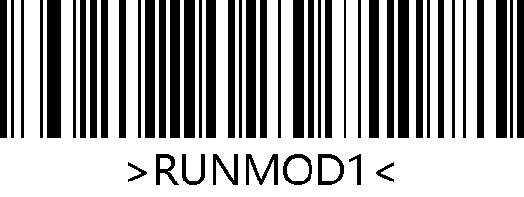
Command triggering mode

Note：In command triggering mode, the serial port command that triggers scanning is: 7E 00 08 01 00 02 01 AB CD; After receiving the trigger command, the scan engine will first output a seven byte response message and synchronously start scanning (response message content: 02 00 00 01 00 33 31).

Decode Session Timeout
In command triggered mode, this parameter refers to the maximum duration the decode session continues before good read. The range of decode session timeout is 0.1~25.5 seconds, with a step size of 0.1 seconds. When set to 0, it indicates an infinite reading time. The default duration is 5.0 seconds.

1000ms
3000ms
*5000ms
Infinite Duration

Illumination & Aiming

Illumination
Illumination can provide auxiliary lighting during every image capture, with a beam of light shining on the target barcode, improving reading performance and adaptability to weak ambient Illumination. Users can set it to one of the following states according to the application environment：
Illumination Normal（default）：The Illumination LEDs turn on during image capture, and turn off at other times;
Illumination Always On：The Illumination LEDs keep on after the engine is powered on;
Illumination Off：The Illumination LEDs keep off all the time.

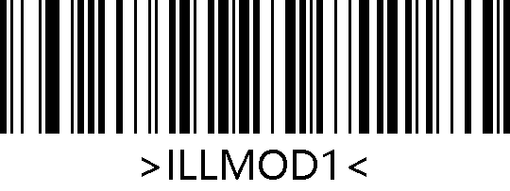
*Illumination Normal
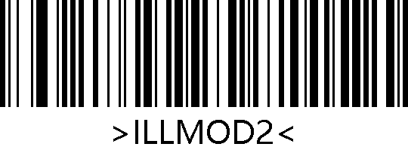
Illumination Always On
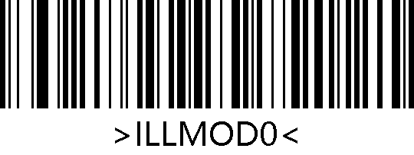
Illumination Off

External Illumination
Users can control the external illumination by scanning the following setting barcodes (hardware connection method can be found in the hardware reference manual).

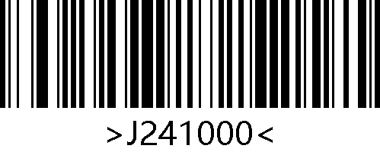
*Disable External Illumination
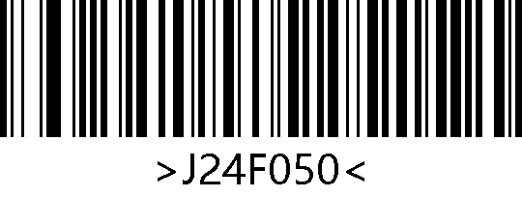
Enabled External Illumination
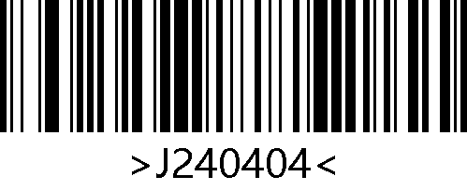
*External Illumination High-level Effective
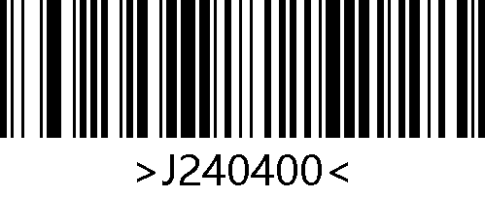
External Illumination Low-level Effective

Aiming
The projected aiming pattern can help users find the optimal reading position during image capture. The user can select any of the following modes according to the application environment:
Aiming Normal:（default）：The engine projects an aiming pattern only during image capture;
Aiming Always ON：Aiming beam is constantly on after the engine is powered on;
Aiming Off：Aiming pattern is off all the time.

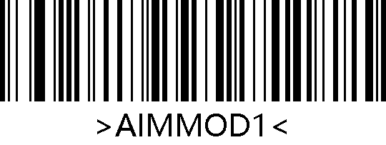
*Aiming Normal
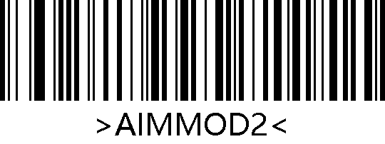
Aiming Always ON
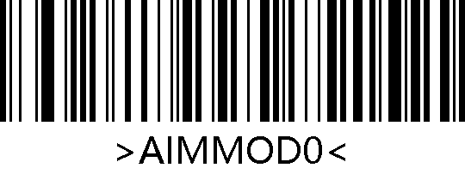
Aiming Off

Beep & LED Notifications

Buzzer

Passive Buzzer
Scan the following setting barcodes to set the driving frequency of the passive buzzer and achieve volume control.

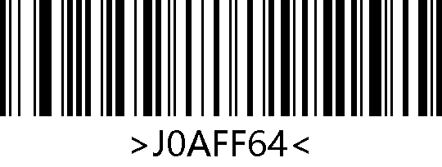
Passive Buzzer - Low Tone
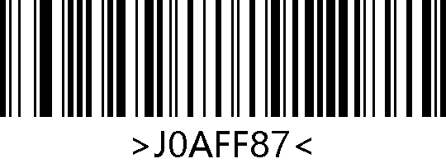
*Passive Buzzer - Medium Tone
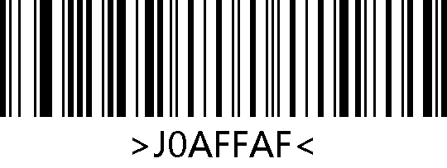
Passive Buzzer - High Tone

Active Buzzer
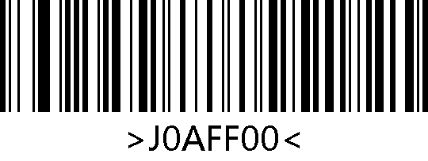
Active buzzer
In active buzzer mode, users can scan the "Buzzer Working Level-High" barcode to set the buzzer to be: idle low level and working high level, and scan the "Buzzer Working Level-Low" barcode to set the buzzer to be: idle high level and working low level.

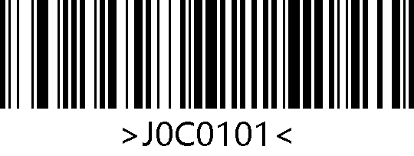
*Buzzer Working Level - High
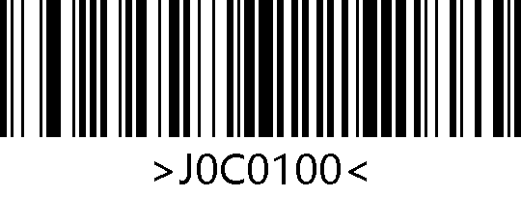
Buzzer Working Level - Low

All Beep
Scan the "Enable Mute" barcode to turn off all beep notifications and scan the "Disable Mute" barcode to cancel mute settings.

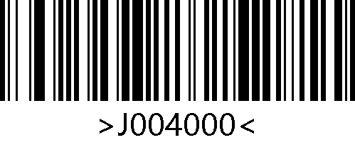
Enable Mute
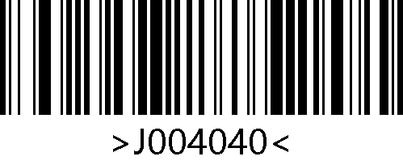
*Disable Mute

Startup Beep
Scanning the "Enable Startup Beep" barcode can enable the startup beep. Scan the "Disable Startup Beep" barcode to disable the startup beep.

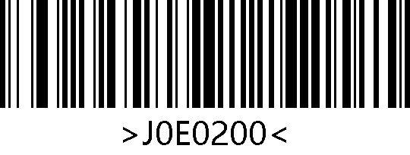
*Enable Startup Beep
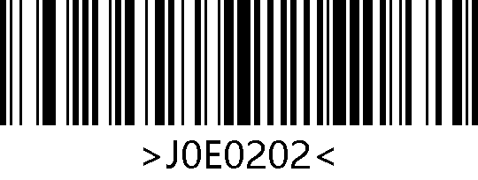
Disable Startup Beep

Good Read Beep
The good read beep includes good read beep for setting barcode and good read beep for Non- setting barcode.
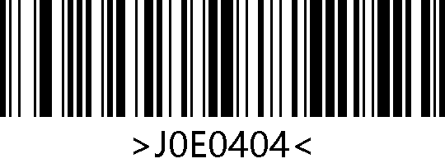
*Enable Good Read Beep
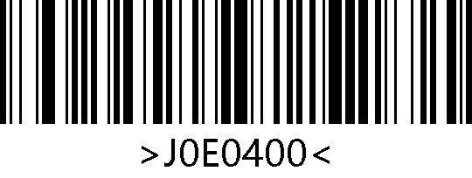
Disable Good Read Beep

Good Read Beep for Setting Barcode
In the [Enable Good Read Beep] state, the following setting barcodes can be scanned separately to enable or disable the good read beep for setting barcode.

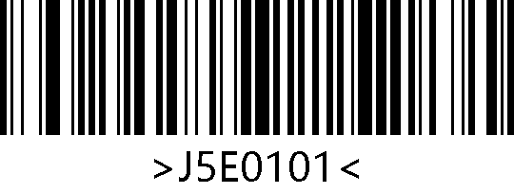
*Enable Good Read Beep for Setting Barcode
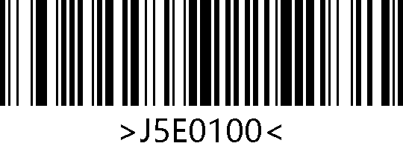
Disable Good Read Beep for Setting Barcode

Good Read Beep for Non-setting Barcode
In the [Enable Good Read Beep] state, the following setting barcodes can be scanned separately to enable or disable the good read beep for Non-setting barcode.

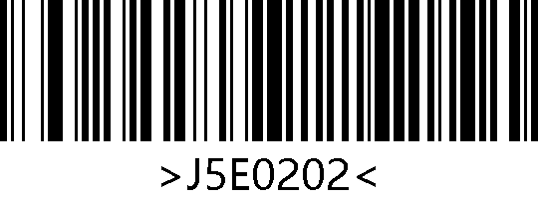
*Enable Good Read Beep for Non-setting Barcode
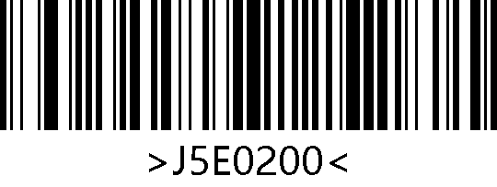
Disable Good Read Beep for Non-setting Barcode

Good Read Beep Timeout
Scanning the "Beep Timeout" barcodes can set good read beep timeout, with a default of 60ms.
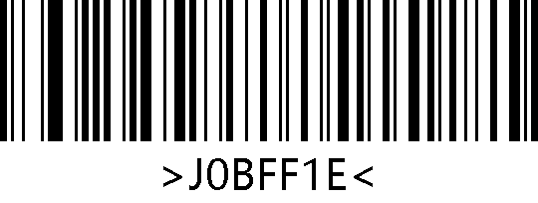
Good Read Beep Timeout-30ms
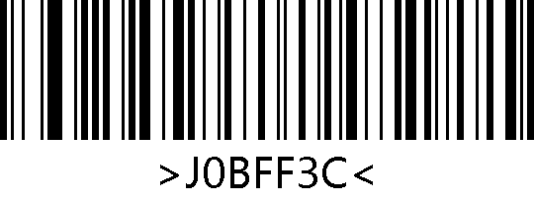
* Good Read Beep Timeout-60ms
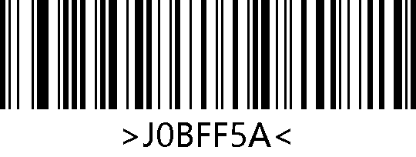
Good Read Beep Timeout-90ms
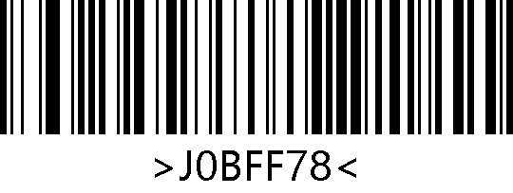
Good Read Beep Timeout-120ms

Startup LED

Enable/Disable Startup LED
Scanning the "Enable Startup LED" barcode can enable the engine to output a high-level pulse on the DLED pin of the 12PIN connector after startup. Scan the "Disable Startup LED" barcode to cancel the high-level pulse output of the DLED pin.

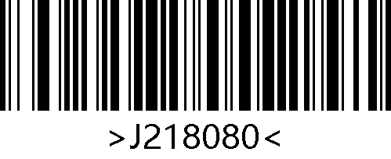
Enable Startup LED
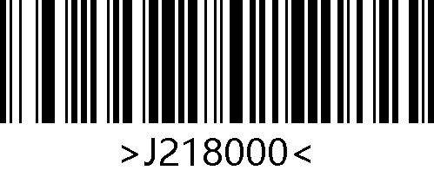
*Disable Startup LED

Startup LED Timeout
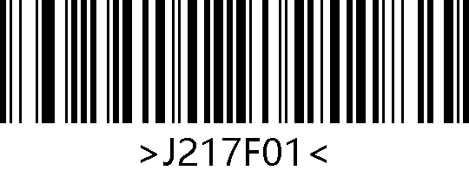
Startup LED Timeout-100ms
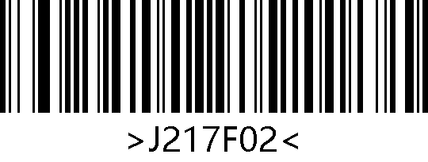
*Startup LED Timeout-200ms
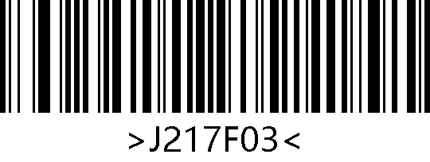
Startup LED Timeout-300ms
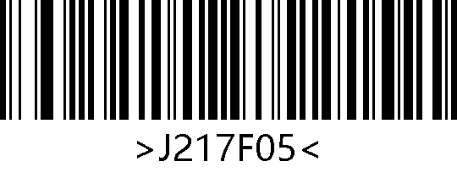
Startup LED Timeout-500ms
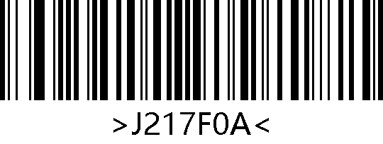
Startup LED Timeout-1000ms
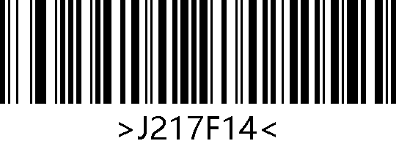
Startup LED Timeout-2000ms

Good Read LED

Enable/Disable Good Read LED
Scanning the "Enable Good Read LED" barcode can enable the engine to output a high-level pulse on the DLED pin of the 12PIN connector after good read. Scanning the "Disable Good Read LED" barcode will cancel the high-level pulse output on the DLED pin.

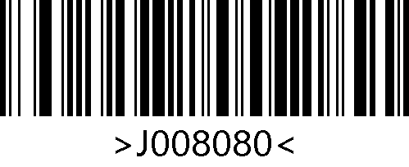
*Enable Good Read LED
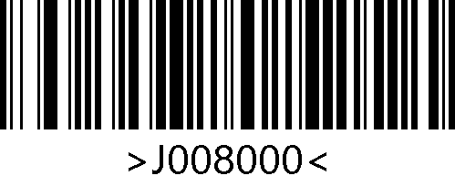
Disable Good Read LED

Good Read LED Timeout
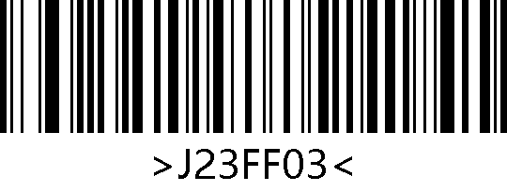
Good Read LED Timeout-30ms
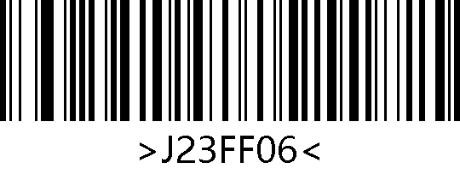
* Good Read LED Timeout-60ms
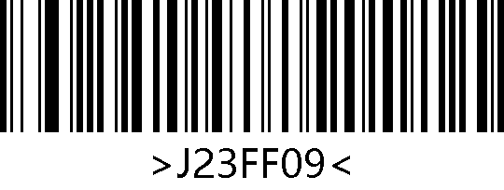
Good Read LED Timeout-90ms
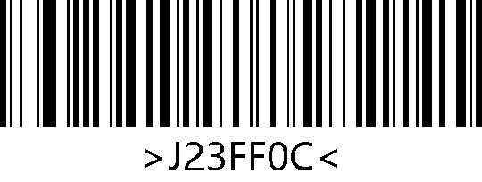
Good Read LED Timeout-120ms
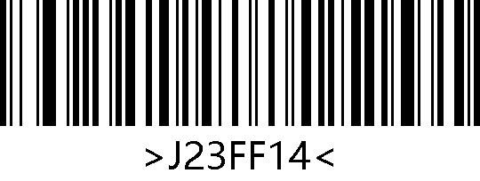
Good Read LED Timeout-200ms
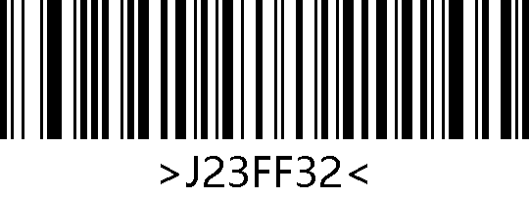
Good Read LED Timeout-500ms

Good Read Vibration

Enable/Disable Good Read Vibration
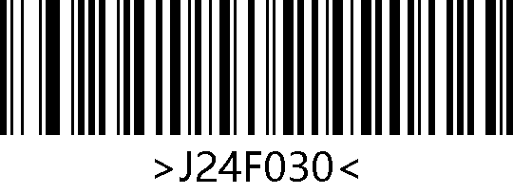
Enable Good Read Vibration
*Disable Good Read Vibration
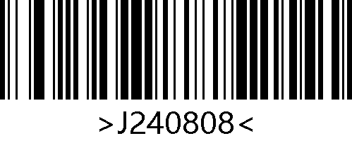
Vibration High-level Effective
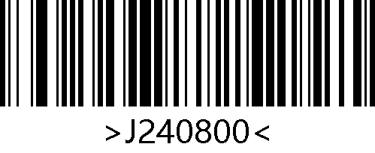
*Vibration Low-level Effective

Good Read Vibration Timeout
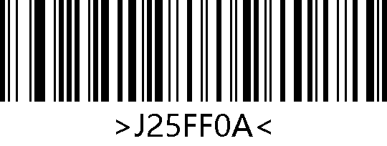
* Good Read Vibration Timeout-100ms
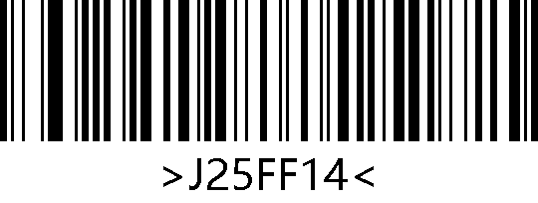
Good Read Vibration Timeout-200ms
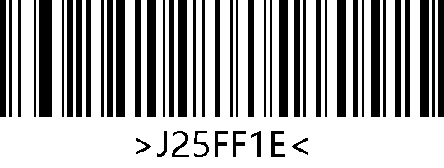
Good Read Vibration Timeout-300ms
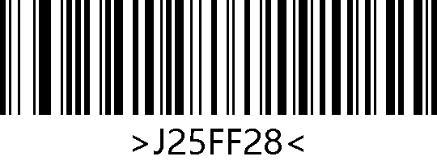
Good Read Vibration Timeout-400ms

Read Fail Message

Transmit RF Message
RF (Read fail) message settings can enable the engine whether or not to transmit a user-defined RF message when a barcode is not good read. Users or programs can make corresponding adjustments or operations after detecting this message.

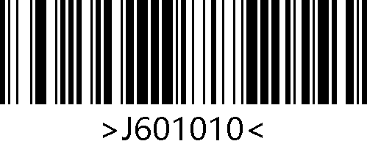
Transmit RF Message
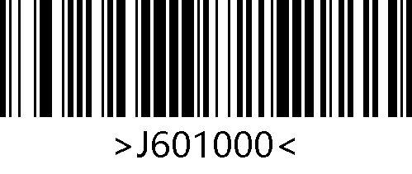
*Do Not Transmit RF Message

Edit RF Message
Users can scan the "Edit RF Message" barcode and the digit barcodes to edit RF message. Each RF character is represented by two hexadecimal values, with a maximum of 15 characters allowed in RF. The hexadecimal conversion table for character values can be referenced (Appendix D: ASCII Table).

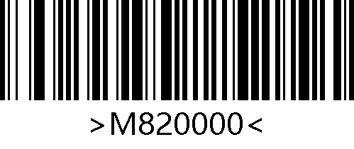
Edit RF Message

Example：Edit user-defined RF Message to "FAIL"
- According to the character table (Appendix D: ASCII Table), the hexadecimal values for the four characters in "FAIL" are: "46", "41", "49", "4C";
- Confirm whether the setting barcode is enabled. If it is not enabled, please scan the "Enter Setup" barcode (see Chapter 2.1);
- Scan the "Edit RF Message" barcode;
- Scan the digit barcodes in sequence (Appendix E: Digit Barcodes) "4", "6", "4", "1", "4", "9", "4", "C";
- Scan the "Save" barcode (Appendix F: Save/Cancel Barcodes).

Date Editing
In practical applications, sometimes the barcode data needs to be edited and distinguished from one another.
Data editing includes：
- Append custom prefix;
- Append AIM ID;
- Append Code ID;
- Append custom suffix;
- Decoded Data segment truncation;
- Append Tail suffix.
The default output order of edited data is as follows：
【Prefix】【AIM ID】【Code ID】【Data】【Suffix】【Tail】

Custom Prefix
Enable/ Disable Custom Prefix
Prefix is the string that can be customized and modified by the user before the decoded data and can be enabled by scanning the "Enable Custom Prefix" barcode.

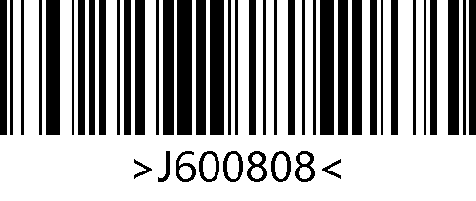
Enable Custom Prefix
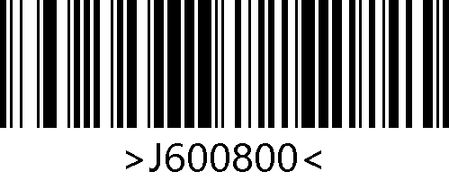
*Disable Custom Prefix
Modify Custom Prefix
Users can scan the "Modify Custom Prefix" barcode and the digit barcodes to modify the prefix. Each prefix character is represented by two hexadecimal values, with a maximum of 15 characters allowed in prefix. The hexadecimal conversion table for character values can be referenced (Appendix D: ASCII Table).

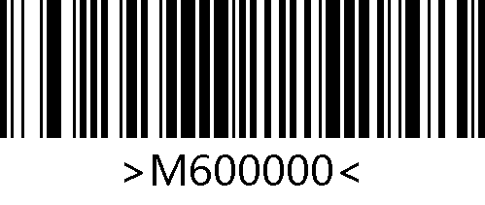
Modify Custom Prefix

Example：Modify the custom prefix to "DATA"
- According to the character table (Appendix D: ASCII Table), the hexadecimal values of the four characters in "DATA" are: "44", "41", "54", "41";
- Confirm whether the setting barcode is enabled. If it is not enabled, please scan the "Enter Setup" barcode (see Chapter 2.1);
- Scan the "Modify Custom Prefix" barcode;
- Scan the digit barcodes in sequence (Appendix E: Digit Barcodes) "4", "4", "4", "1", "5", "4", "4", "1";
- Scan the "Save" barcode (Appendix F: Save/Cancel Barcodes).

AIM ID Prefix
AIM is the abbreviation for Automatic Identification Manufacturers. The AIM IDs define symbology identifiers (Users cannot customize the AIM ID). The specific definition can be found in Appendix B: AIM ID Table. If AIM ID Prefix is enabled, the engine will add the symbology identifier before the barcode data after decoding with the following format: "]"+letter "C"+ number "0". For example, the AIM ID of Code 128 is "]C0".

Enable/ Disable AIM ID Prefix
Users can identify different barcode types through AIM IDs, but the corresponding AIM ID for each barcode type cannot be modified by users. The AIM ID consists of three characters.

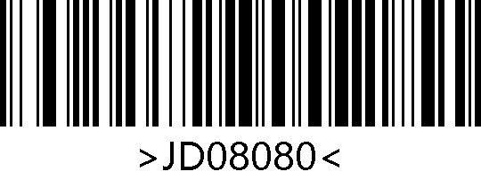
Enable AIM ID Prefix
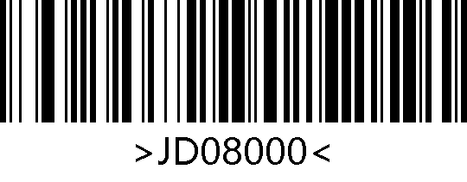
*Disable AIM ID Prefix

Code ID Prefix
Enable/ Disable Code ID Prefix
Users can also identify different barcode types through Code IDs, and the corresponding Code ID for each barcode type can be modified by the users. The Code ID consists of one character.

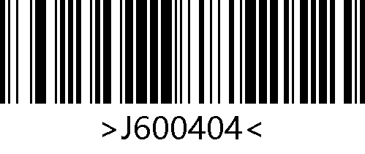
Enable Code ID Prefix
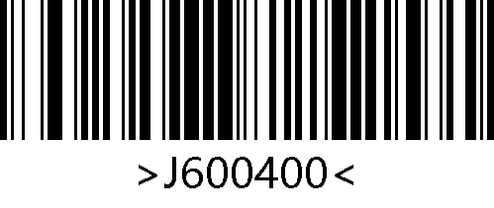
*Disable Code ID Prefix
Restore All Default Code IDs
Scan the "Restore All Default Code IDs" barcode, the corresponding Code ID for each barcode can be restored to the default value. The default Code ID can be referred to (Appendix C: Code ID Table).

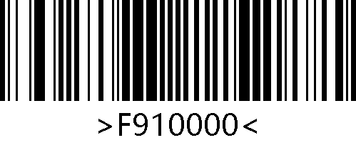
*Restore All Default Code IDs

Modify Code ID
Users can modify the Code ID corresponding to each barcode by scanning the corresponding barcode and the digit barcodes. The Code ID is represented by one hexadecimal value, and the hexadecimal conversion table for character values can be referred to (Appendix D: ASCII Table).
Example：Modify the Code128 Code ID to "A"
- According to the character table (Appendix D: ASCII Table), the hexadecimal value of character "A" is "41";
- Confirm whether the setting barcode is enabled. If it is not enabled, please scan the "Enter Setup" code (see Chapter 2.1);
- Scan the "Modify Code128 Code ID " barcode;
- Scan the digit barcodes in sequence (Appendix E: Digit Barcodes) "4", "1";
- Scan the "Save" barcode (Appendix F: Save/Cancel Barcodes).

Modifying Code ID Setting Barcodes List:

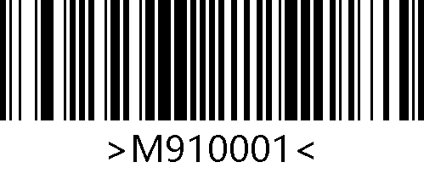
Modify Aztec Code ID
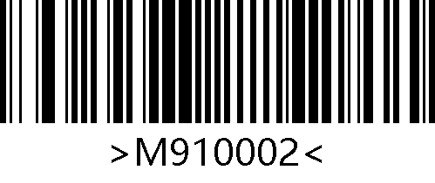
Modify Codabar Code ID
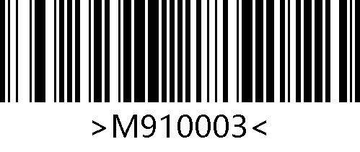
Modify Code39 Code ID
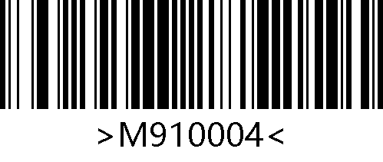
Modify Code93 Code ID
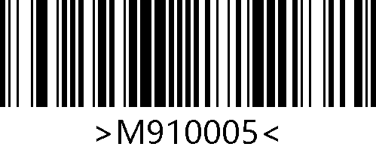
Modify Code128 Code ID
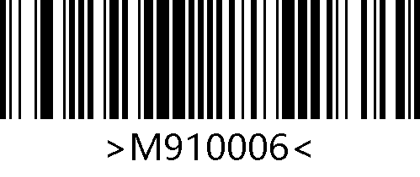
Modify GS1 DataBar(RSS14) Code ID
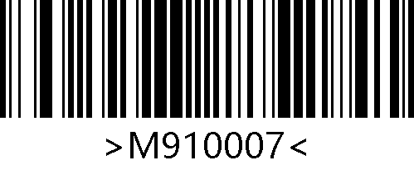
Modify GS1 DataBar Expanded Code ID
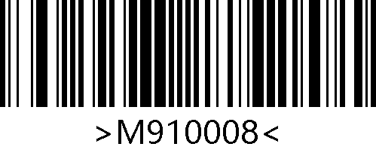
Modify Data Matrix Code ID
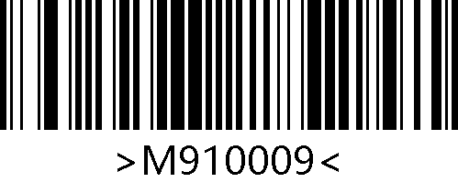
Modify EAN-8 Code ID
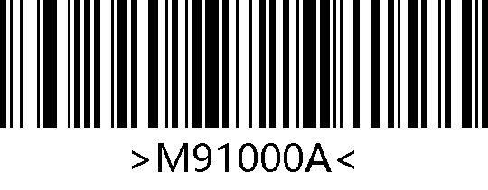
Modify EAN-13 Code ID
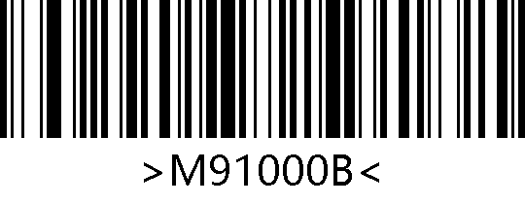
Modify Interleaved 2 of 5 Code ID
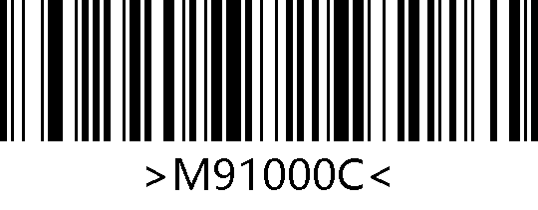
Modify Maxi Code ID
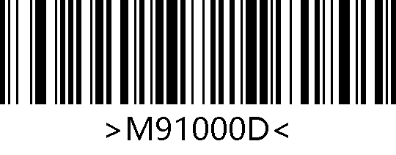
Modify PDF417 Code ID
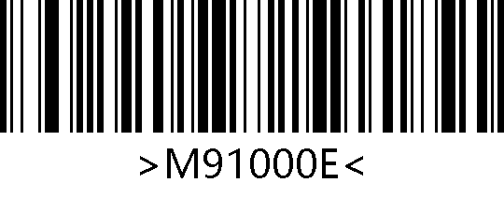
Modify QR Code ID
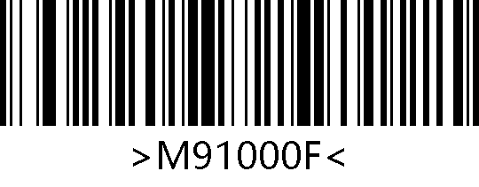
Modify UPC-A Code ID
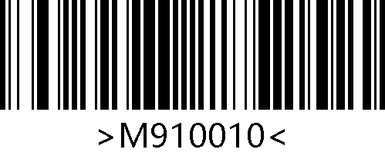
Modify UPC-E Code ID
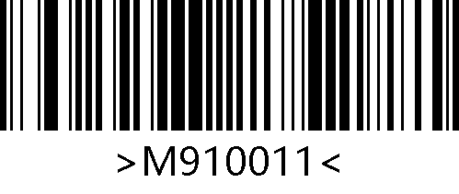
Modify Micro QR Code ID
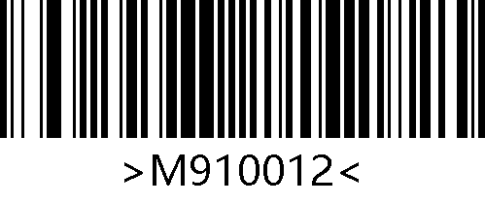
Modify MSI Plessey Code ID
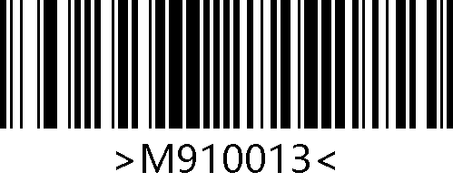
Modify Industrial 2 of 5 Code ID
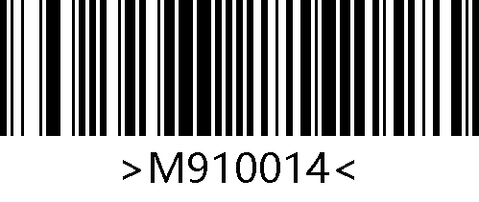
Modify Matrix 2 of 5 Code ID
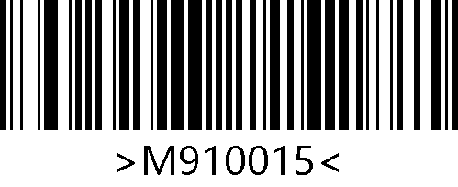
Modify Code11 Code ID
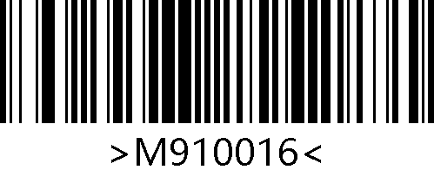
Modify ISSN Code ID
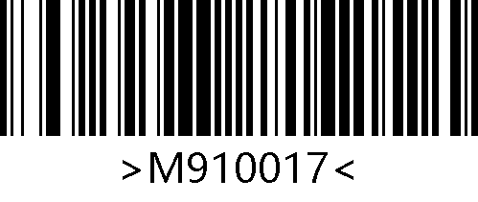
Modify ISBN Code ID
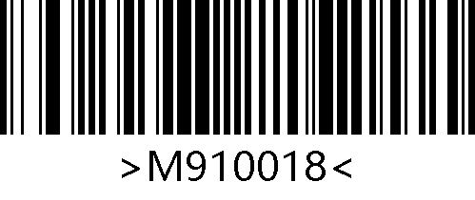
Modify GS1 DataBar Limited Code ID
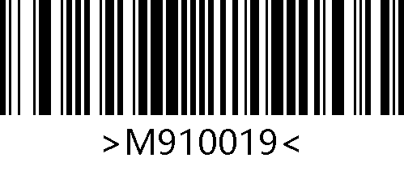
Modify Micro PDF417 Code ID
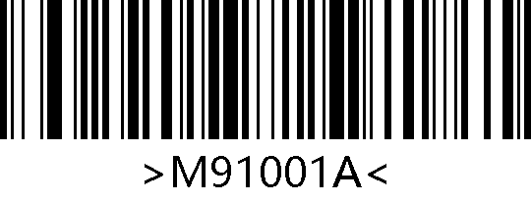
Modify Code32 Code ID

Data Segment Truncation
This function can be enabled when the user only needs to output a portion of the decoding data.
The decode information [Data] can be divided into three parts: [Start], [Center], and [End].
The character length of the Start and End segments can be configured by scanning barcodes.
Users can choose to output decoding information at the corresponding position by scanning the following setting barcodes.

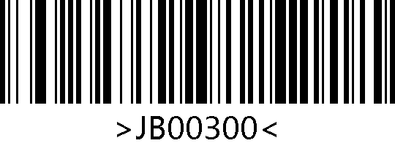
* Transmit Entire Data Segment
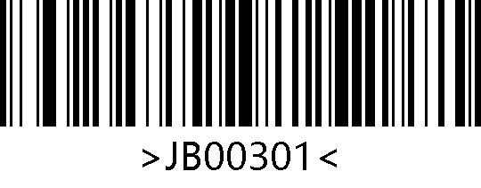
Only Transmit Start Segment
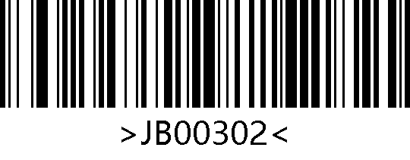
Only Transmit End Segment
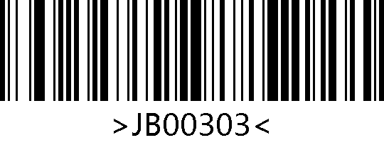
Only Transmit Center Segment

Modify Start Truncation Length M
Users can scan the "Start Truncation Length M" barcode and the digit barcodes to modify the length of the Start segment. The truncation length M is represented by one hexadecimal character, with a maximum of 255 characters allowed in Start segment. The hexadecimal value conversion table corresponding to the length M can be referred to (Appendix D: ASCII Table).

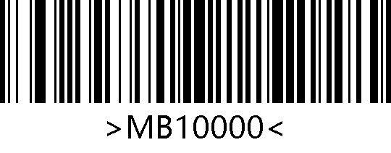
Start Truncation Length M

Modify End Truncation Length N
Users can scan the "End Truncation Length N" barcode and the digit barcodes to modify the length of the End segment. The truncation length N is represented by one hexadecimal character, with a maximum of 255 characters allowed in End segment. The hexadecimal value conversion table corresponding to the length N can be referred to (Appendix D: ASCII Table).

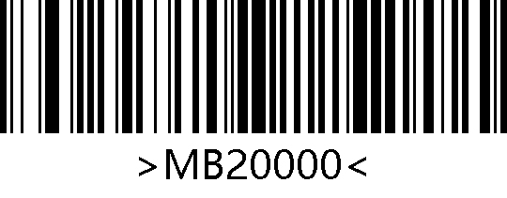
End Truncation Length N

Only Transmit Start Segment
Example：When decoding information is "1234567890123ABC", output the first thirteen bytes "1234567890123"
- According to the character table (Appendix D: ASCII Table), the hexadecimal character corresponding to decimal data "13" is "0D";
- Confirm whether the setting barcode is enabled. If it is not enabled, please scan the "Enter Setup" barcode (see Chapter 2.1);
- Scan the "Start Truncation Length M" barcode;
- Scan the digit barcodes in sequence (Appendix E: Digit Barcodes) "0", "D";
- Scan the "Save" barcode (Appendix F: Save/Cancel Barcodes);
- Scan the "Only Transmit Start Segment" barcode.

Only transmit End segment
Example：When decoding information is "1234567890123ABC", output the last three bytes "ABC"
- According to the character table (Appendix D: ASCII Table), the hexadecimal character corresponding to decimal data "3" is "03";
- Confirm whether the setting barcode is enabled. If it is not enabled, please scan the "Enter Setup" barcode (see Chapter 2.1);
- Scan the "End Truncation Length N" barcode;
- Scan the digit barcodes in sequence (Appendix E: Digit Barcodes) "0", "3";
- Scan the "Save" barcode (Appendix F: Save/Cancel Barcodes);
- Scan the "Only Transmit End Segment" barcode.

Only transmit the Center segment
Example：When decoding information is "12345678900123ABC", output the middle four bytes "0123"
- According to the character table (Appendix D: ASCII Table), the hexadecimal characters corresponding to decimal data "10" and "3" are "0A" and "03";
- Confirm whether the setting barcode is enabled. If it is not enabled, please scan the "Enter Setup" barcode (see Chapter 2.1);
- Scan the "End Truncation Length N" setting barcode；
- Scan the digit barcodes in sequence (Appendix E: Digit Barcodes) "0", "3";
- Scan the "Save" barcode (Appendix F: Save/Cancel Barcodes);
- Scan the "Start Truncation Length M" barcode;
- Scan the digit barcodes in sequence (Appendix E: Digit Barcodes) "0", "A";
- Scan the "Save" barcode (Appendix F: Save/ Cancel Barcodes);
- Scan the "Only Transmit Center Segment" barcode.

Custom Suffix
Enable/ Disable Custom Suffix
The suffix is the string that can be customized and modified by the user after the decoded data and can be enabled by scanning the "Enable Custom Suffix" barcode.

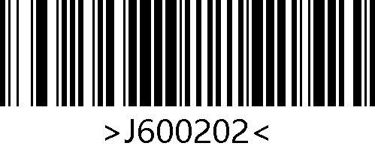
Enable Custom Suffix
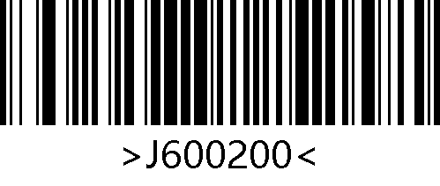
*Disable Custom Suffix
Modify Custom Suffix
Users can scan the "Modify Custom Suffix" barcode and the digit barcodes to modify the suffix. Each suffix character is represented by two hexadecimal values, with a maximum of 15 characters allowed in suffix. The hexadecimal conversion table for character values can be referred to (Appendix D: ASCII Table).

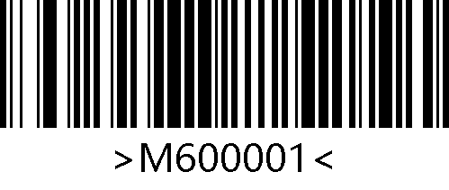
Modify Custom Suffix

Example：Modify the Custom Suffix to "DATA"
- According to the character table (Appendix D: ASCII Table), the hexadecimal values of the four characters in "DATA" are: "44", "41", "54", "41";
- Confirm whether the setting barcode is enabled. If it is not enabled, please scan the "Enter Setup" barcode (see Chapter 2.1);
- Scan the "Modify Custom Suffix" barcode;
- Scan the digit barcodes in sequence (Appendix E: Digit Barcodes) "4", "4", "4", "1", "5", "4", "4", "1";
- Scan the "Save" barcode (Appendix F: Save/Cancel Barcodes).

Tail Suffix
To enable the host to quickly distinguish the current decoding result, this function can be enabled.
After scanning the "Modify Tail Suffix" barcodes, if good read, the engine will add the corresponding tail suffix after the decoded data.

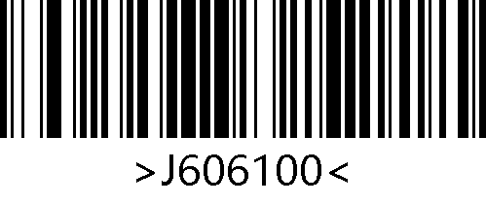
Disable Tail Suffix
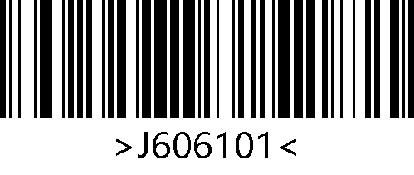
*Modify Tail Suffix to CR
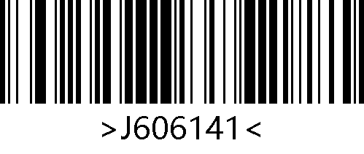
Modify Tail Suffix to TAB
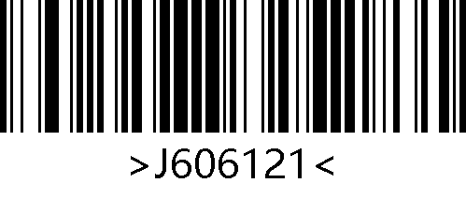
Modify Tail Suffix to CRLF
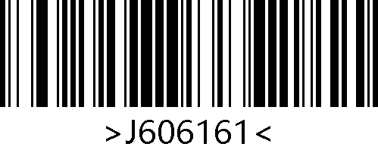
Modify Tail Suffix to Two CRLF
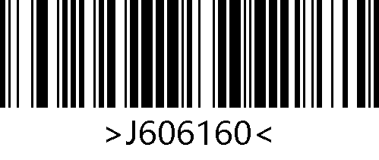
Modify Tail Suffix to CRDownArrow

Transmit Protocol
By scanning the following settings barcode, the transmit format of decoded data in serial/virtual serial mode can be modified.
Among them, the transmit format with protocol is: <03><length><decoded data>.

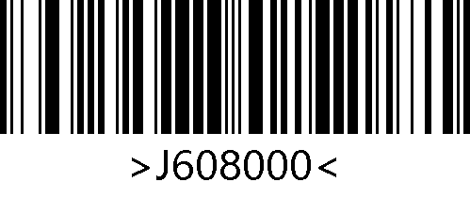
*Raw Data
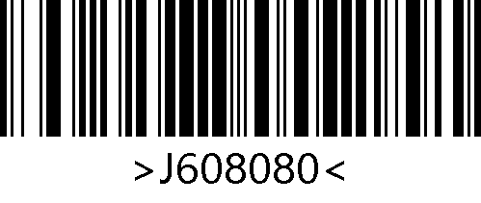
With Protocol

HID KBW Output Compatibility
Users can switch the compatibility of HID KBW by scanning the following barcodes.

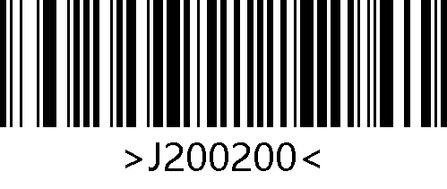
*Compatibility Mode 1
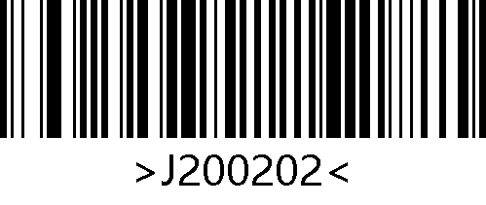
Compatibility Mode 2

Symbologies

Enable/Disable All Symbologies
Scanning the following barcodes will enable or disable symbologies. If all symbologies disabled, only the setting barcodes can be read.

Enable All Symbologies
Disable All Symbologies
* Enable Default Symbologies

Video Reverse
In some special scenarios, the following barcodes can configure the engine to read regular and inverse barcodes. If enabled, it will affect the reading speed. Please enable it in the desired scenario.

*1D Regular Symbologies
1D Regular and Inverse Symbologies
* Regular QR
Regular and Inverse QR
* Regular DM
Regular and Inverse DM

EAN-13

Enable/Disable EAN-13
Scan the following barcodes to enable/disable EAN-13.

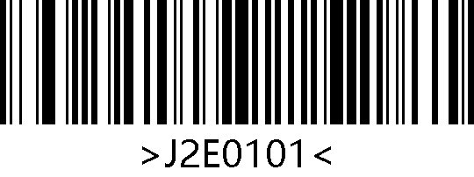
*Enable EAN-13
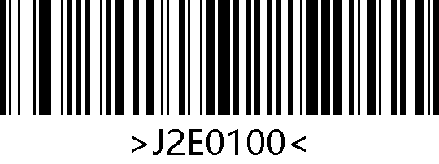
Disable EAN-13

EAN-13 Transmit Check Digit
EAN-13 is 13 digits in length with the last one as its check digit used to verify the integrity of the data. The EAN-13 transmission check digit function can be enabled or disabled by scanning the following setting barcodes.

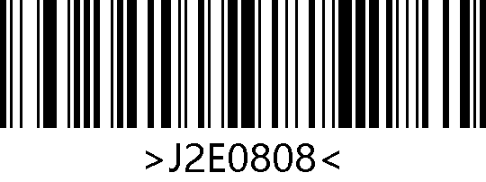
*Transmit EAN-13 Check Digit
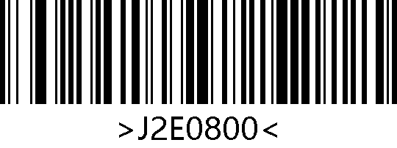
Do Not Transmit EAN-13 Check Digit

EAN-13 Add-On Code
Scan the following setting barcodes to enable or disable the EAN-13 add-on code.

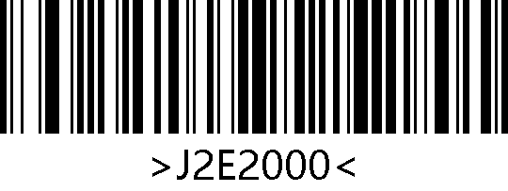
*Disable 2-Digit Add-On Code
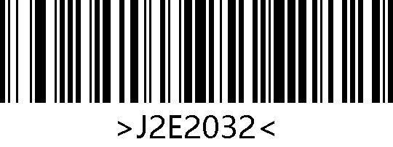
Enable 2-Digit Add-On Code
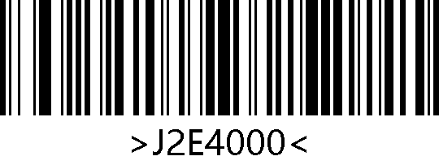
*Disable 5-Digit Add-On Code
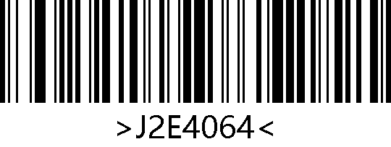
Enable 5-Digit Add-On Code

EAN-13 Add-On Code Required
Scan the following setting barcodes to configure the engine to read EAN-13 barcodes that whether or not need to contain add-on code.

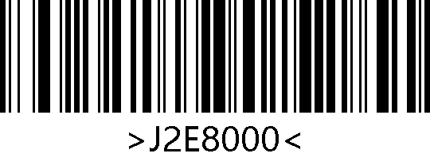
*EAN-13 Add-On Code Not Required
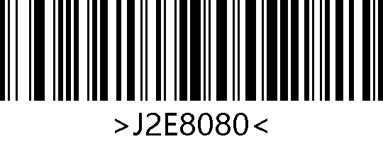
EAN-13 Add-On Code Required

ISSN

Enable/Disable ISSN
Scan the following setting barcodes to enable /disable ISSN.

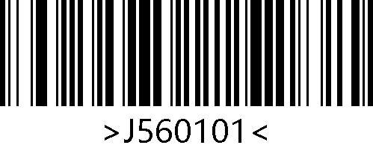
Enable ISSN
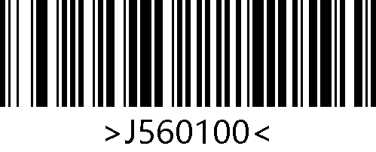
*Disable ISSN

ISSN Add-On Code
Scan the following setting barcodes to enable or disable the ISSN add-on code.

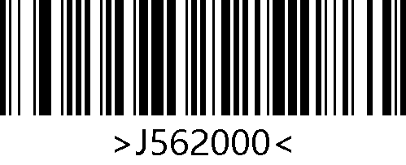
*Disable 2-Digit Add-On Code
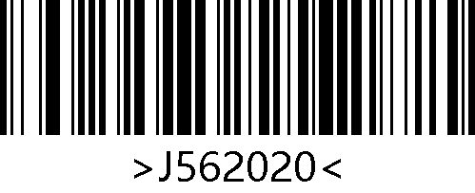
Enable 2-Digit Add-On Code

ISSN Add-On Code Required
Scan the following setting barcodes to configure the engine to read ISSN barcodes that whether or not need to contain add-on code.

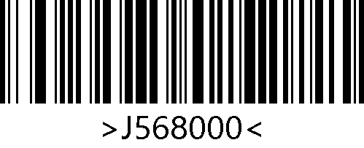
*ISSN Add-On Code Not Required
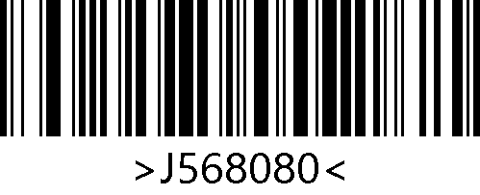
ISSN Add-On Code Required

ISBN

Enable/Disable ISBN
Scan the following setting barcodes to enable/disable ISBN.

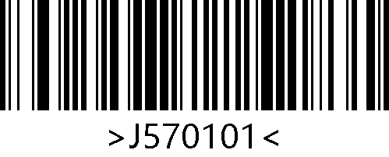
Enable ISBN
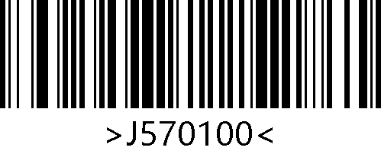
*Disable ISBN

ISBN Add-On Code
Scan the following setting barcodes to enable or disable the ISBN add-on code.

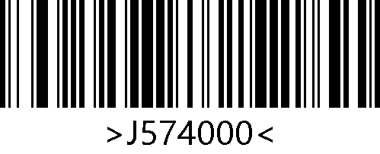
*Disable 5-Digit Add-On Code
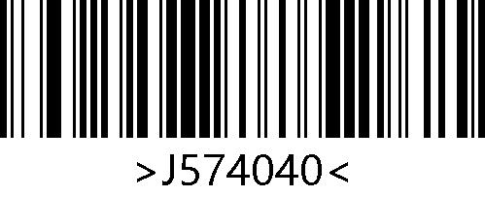
Enable 5-Digit Add-On Code

ISBN Add-On Code Required
Scan the following setting barcodes to configure the engine to read ISBN barcodes that whether or not need to contain add-on code.

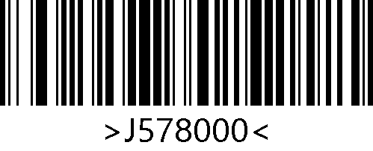
*ISBN Add-On Code Not Required
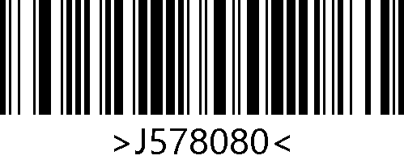
ISBN Add-On Code Required

EAN-8

Enable/Disable EAN-8
Scan the following setting barcodes to enable/disable EAN-8.

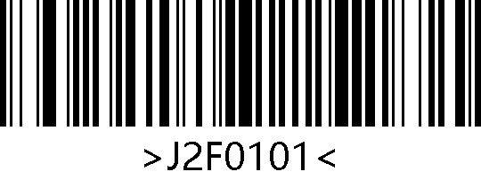
*Enable EAN-8
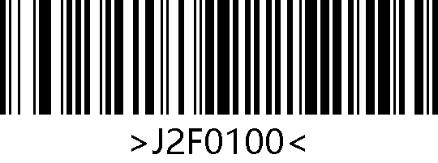
Disable EAN-8

EAN-8 Transmit Check Digit
EAN-8 is 8 digits in length with the last one as its check digit used to verify the integrity of the data. The EAN-8 transmission check digit function can be enabled or disabled by scanning the following setting barcodes.

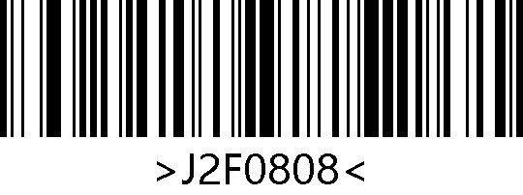
*Transmit EAN-8 Check Digit
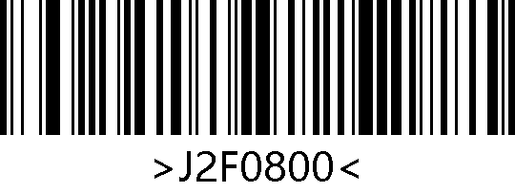
Do Not Transmit EAN-8 Check Digit

EAN-8 Add-On Code
Scan the following setting barcodes to enable or disable the EAN-8 add-on code.

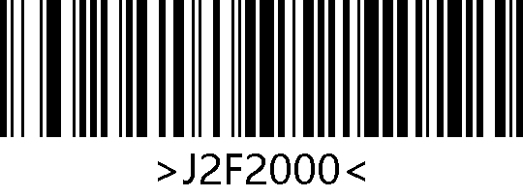
*Disable 2-Digit Add-On Code
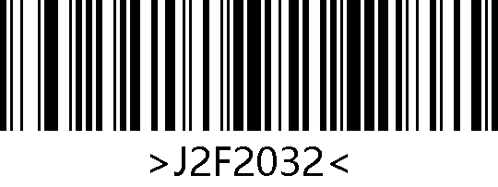
Enable 2-Digit Add-On Code
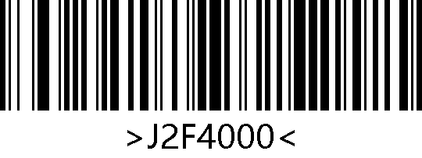
*Disable 5-Digit Add-On Code
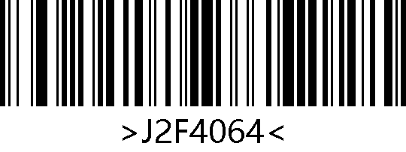
Enable 5-Digit Add-On Code

EAN-8 Add-On Code Required
Scan the following setting barcodes to configure the engine to read EAN-8 barcodes that whether or not need to contain add-on code.

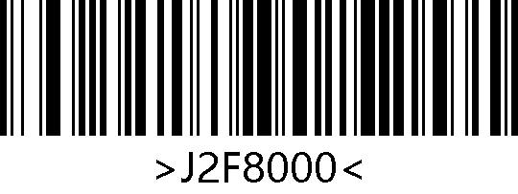
* EAN-8 Add-On Code Not Required
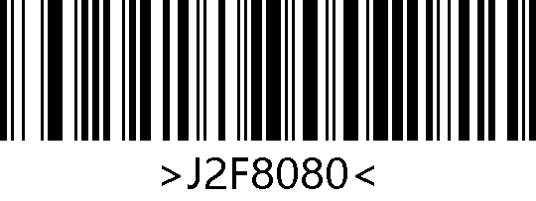
EAN-8 Add-On Code Required

EAN-8 to EAN-13
The function of converting EAN-8 to EAN-13 can be enabled or disabled by scanning the following setting barcodes.

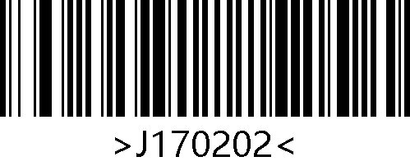
Enable EAN-8 to EAN-13
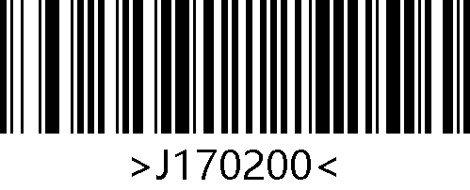
*Disable EAN-8 to EAN-13

UPC-A

Enable/Disable UPC-A
Scan the following setting barcodes to enable/disable UPC-A.

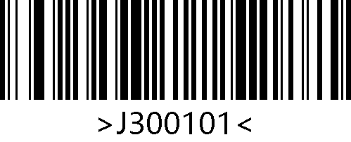
*Enable UPC-A
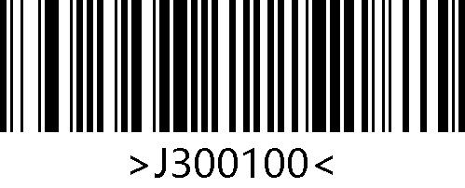
Disable UPC-A

UPC-A Transmit Check Digit
UPC-A is 13 digits in length with the last one as its check digit used to verify the integrity of the data. The UPC-E transmission check digit function can be enabled or disabled by scanning the following setting barcodes.

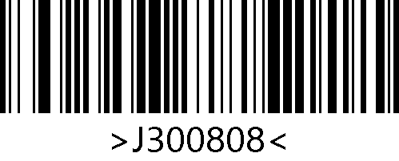
*Transmit UPC-A Check Digit
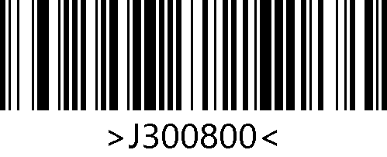
Do Not Transmit UPC-A Check Digit

UPC-A Add-On Code
Scan the following setting barcodes to enable or disable the UPC-A add-on code.

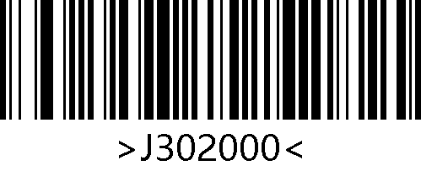
*Disable 2-Digit Add-On Code
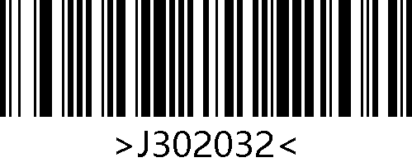
Enable 2-Digit Add-On Code
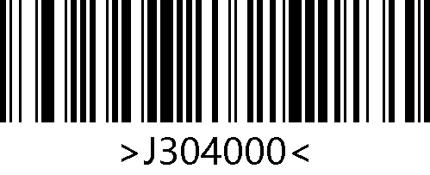
*Disable 5-Digit Add-On Code
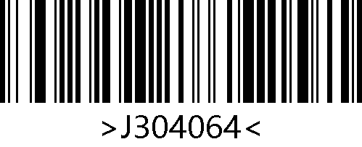
Enable 5-Digit Add-On Code

UPC-A Add-On Code Required
Scan the following setting barcodes to configure the transmit mode of UPC-A.

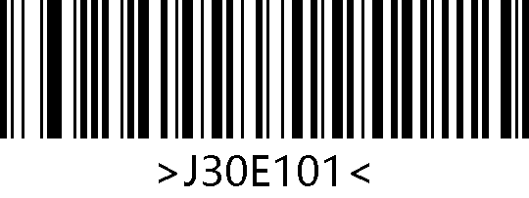
* UPC-A without Add-On Code
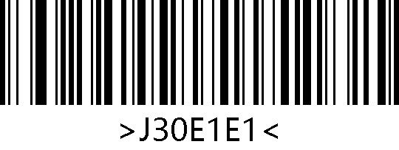
UPC-A with Add-On Code

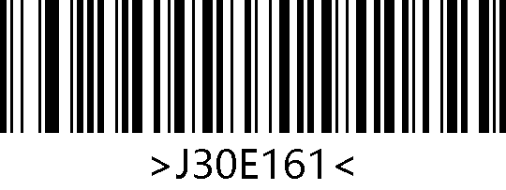
UPC-A Add-On Code Not Required

UPC-A to EAN-13
The function of converting UPC-A to EAN-13 can be enabled or disabled by scanning the following setting barcodes.

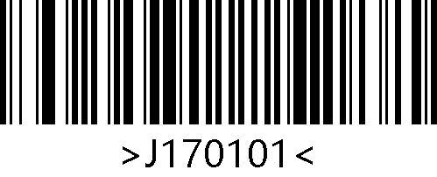
Enable UPC-A to EAN-13
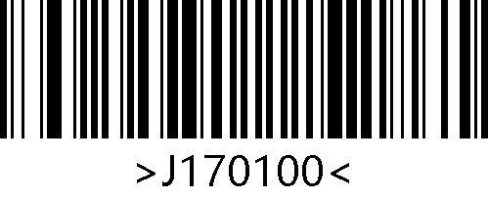
*Disable UPC-A to EAN-13

UPC-E

Enable/Disable UPC-E
Scan the following setting barcodes to enable/disable UPC-E.

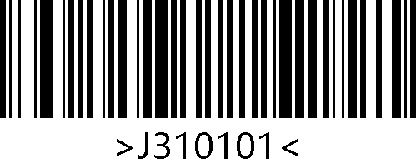
*Enable UPC-E
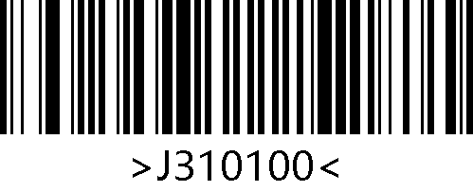
Disable UPC-E

UPC-E Transmit Check Digit
UPC-E is 8 digits in length with the last one as its check digit used to verify the integrity of the data. The UPC-E transmission check digit function can be enabled or disabled by scanning the following setting barcodes.

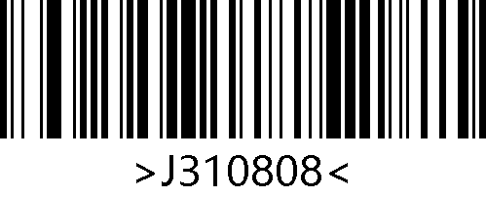
*Transmit UPC-E Check Digit
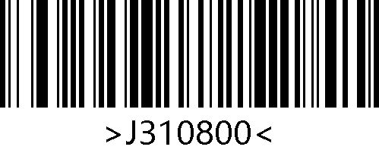
Do Not Transmit UPC-E Check Digit

UPC-E Add-On Code
Scan the following setting barcodes to enable or disable the UPC-E add-on code.

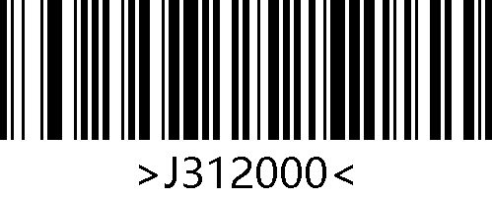
*Disable 2-Digit Add-On Code
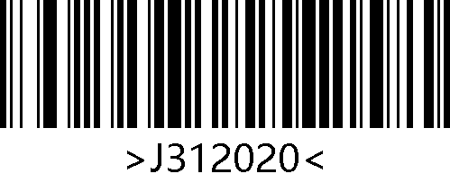
Enable 2-Digit Add-On Code
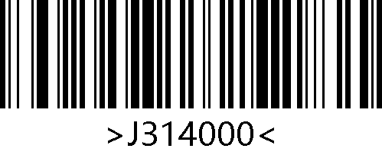
*Disable 5-Digit Add-On Code
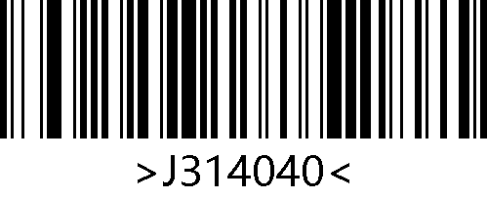
Enable 5-Digit Add-On Code

UPC-E Add-On Code Required
Scan the following setting barcodes to configure the engine to read UPC-E barcodes that whether or not need to contain add-on code.

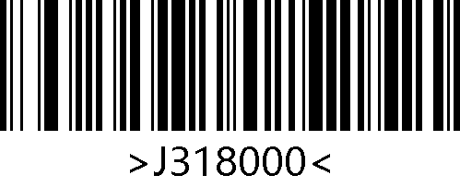
* UPC-E Add-On Code Not Required
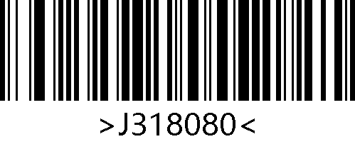
UPC-E Add-On Code Required

UPC-E to UPC-A
The function of converting UPC-E to UPC-A can be enabled or disabled by scanning the following setting barcodes.

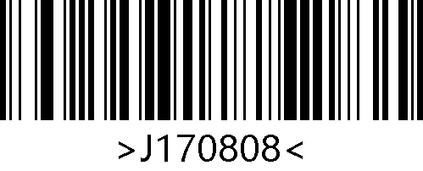
Enable UPC-E to UPC-A
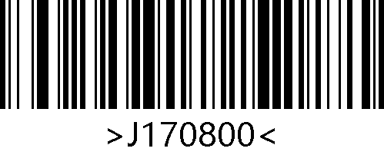
*Disable UPC-E to UPC-A

Code128

Enable/Disable Code128
Scan the following setting barcodes to enable/disable Code128.

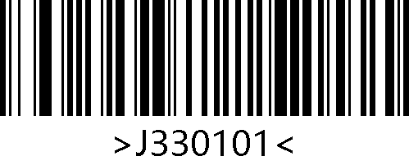
*Enable Code128
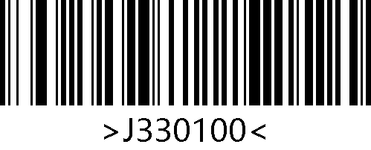
Disable Code128

Set Length for Code 128
Scan the following setting barcodes to set the minimum length for Code128.

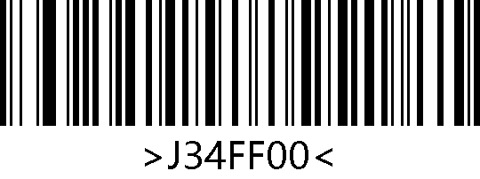
Set the Minimum Length to 0
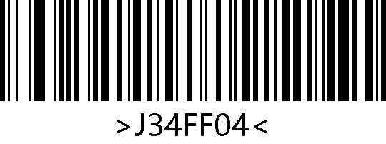
*Set the Minimum Length to 4

Code39

Enable/Disable Code39
Scan the following setting barcodes to enable/disable Code39.

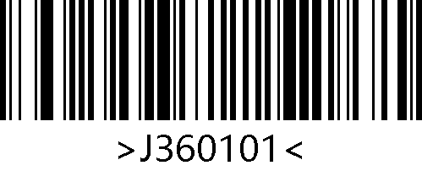
* Enable Code39
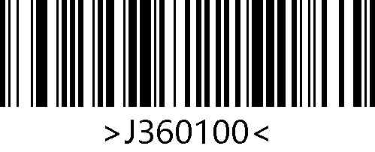
Disable Code39

Set Length for Code39
Scan the following setting barcodes to set the minimum length for Code39.

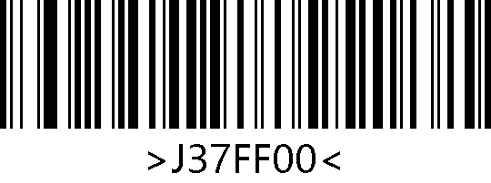
Set the Minimum Length to 0
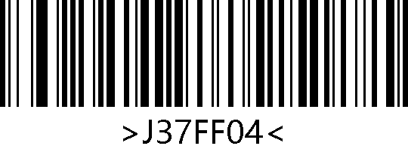
*Set the Minimum Length to 4

Code39 Check Digit Verification (Modulo 43)
Code 39 does not require the inclusion of check digit in barcode data. If there is, it must be the last byte of the data. The check digit value is calculated from all data except for the check digit, used to verify the integrity of the data.
- If set to "Disable Code39 Verification", the scanner will transmit all barcode data normally.
- Set to "Do Not Transmit Check Digit after Verification", the scanner will verify according to the last digit of the barcode data. If the verification passes, the normal data except for the last check digit will be transmitted. If the verification fails, the barcode content will not be sent.
- If set to "Transmit Check Digit after Verification ", the scanner will verify according to the last digit of the barcode data. If the verification passes, the check digit will be transmitted together as the last digit of normal data. If the verification fails, the barcode content will not be sent.

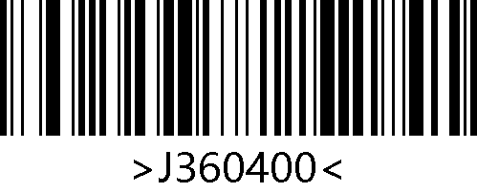
*Disable Code39 Verification
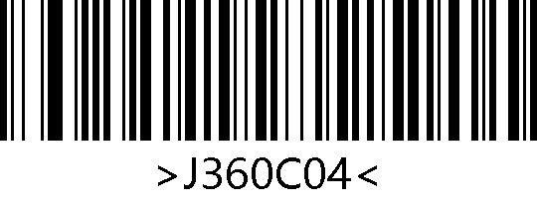
Do Not Transmit Check Digit after Verification
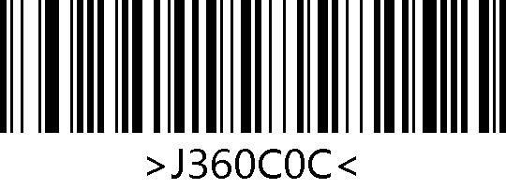
Transmit Check Digit after Verification

When set to "Do Not Transmit Check Digit after Verification", if the data length that minus 1 byte of check digit is less than the minimum length limit, the barcode reading will fail.
For example, in the current scanner settings, the minimum length for Code 39 is 4 bytes, if do not transmit check digit, reading Code 39 with a total length of 4 bytes will fail！

Code39 Transmit Start/Stop Character
Scan the following setting barcodes to configure the start and stop character output of Code39.

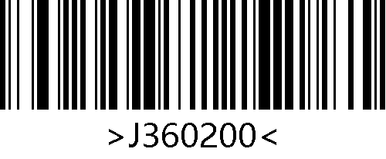
*Do Not Transmit Start Character

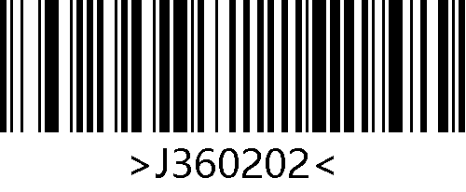
Transmit Start Character
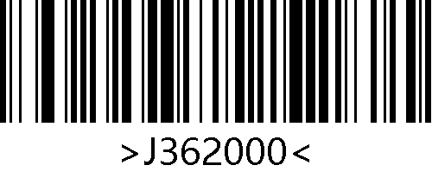
*Do Not Transmit Stop Character
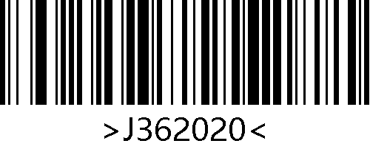
Transmit Stop Character

Enable/Disable Code39 Full ASCII
Scan the “Enable Code39 Full ASCII” barcode to configure the engine to read all ASCII characters.

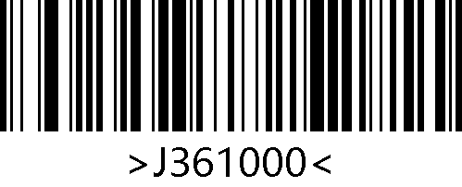
*Disable Code39 Full ASCII
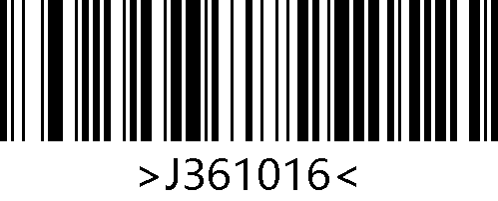
Enable Code39 Full ASCII

Code32

Enable/Disable Code32
Scan the following setting barcodes to enable/disable Code32.

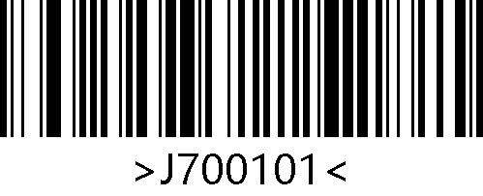
Enable Code32
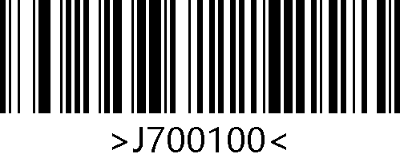
*Disable Code32

Code32 Transmit Check Digit
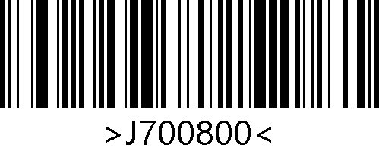
Do Not Transmit Code32 Check Digit
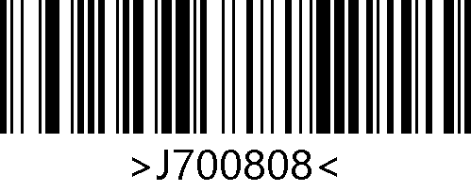
*Transmit Code32 Check Digit

Code32 Transmit Start/Stop Character
Scan the following setting barcodes to configure the start/stop character output of Code32.

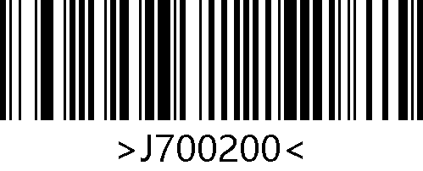
*Do Not Transmit Start Character
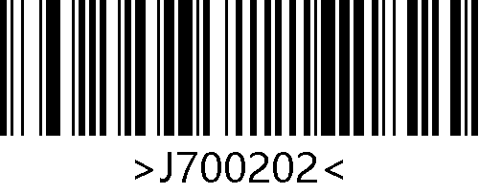
Transmit Start Character
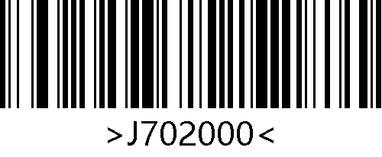
*Do Not Transmit Stop Character
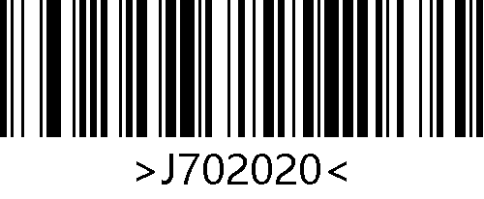
Transmit Stop Character

Code32 Transmit Prefix Character
Scan the following setting barcodes to configure the prefix character output of Code32.

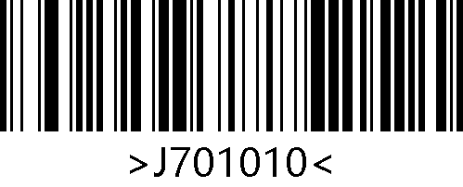
Transmit Prefix Character A
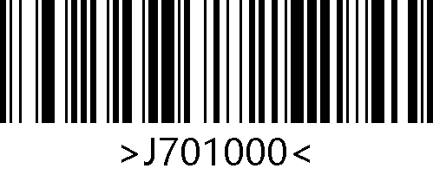
*Do Not Transmit Prefix Character A

Code93

Enable/Disable Code93
Scan the following setting barcodes to enable/disable Code93.

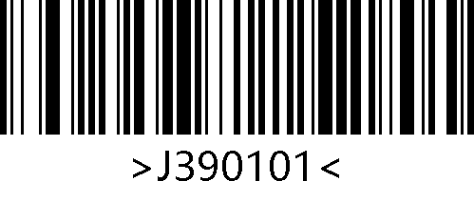
*Enable Code 93
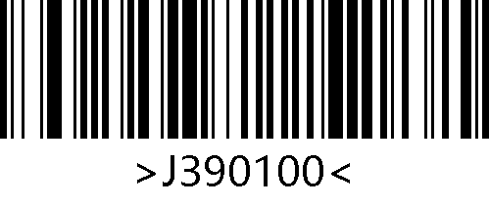
Disable Code 93

Set Length for Code 93
Scan the following setting barcodes to set the minimum length for Code93.

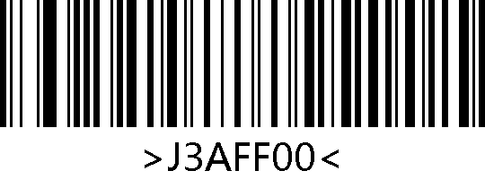
Set the Minimum Length to 0
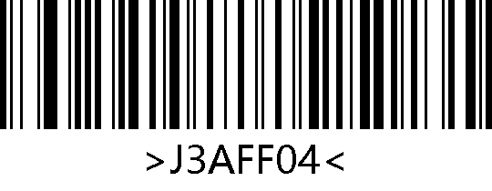
*Set the Minimum Length to 4

Code93 Check Digit Verification
Code93 barcode data does not require the inclusion of check digit. If there is, they must be the last two digits of the data. The check digit value is calculated from all data except for the check digit, used to verify the integrity of the data.
- If set to "Disable Code93 Verification", the scanner will transmit all barcode data normally.
- Set to "Do Not Transmit Check Digit after Verification", the scanner will verify according to the last two digits of the barcode data. If the verification passes, the normal data except for the last two check digits will be transmitted. If the verification fails, the barcode content will not be sent.
- If set to "Transmit Check Digit after Verification", the scanner will verify according to the last two digits of the barcode data. If the verification passes, the check digits will be transmitted together as the last two digits of normal data. If the verification fails, the barcode content will not be sent.

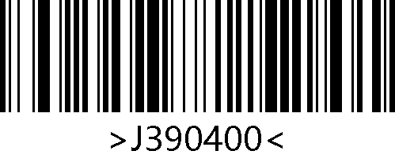
Disable Code93 Verification
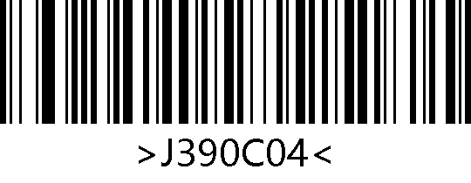
*Do Not Transmit Check Digit after Verification
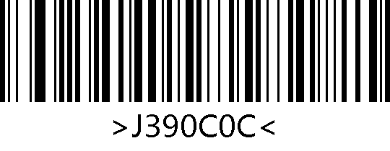
Transmit Check Digit after Verification

When set to "Do Not Transmit Check Digit after Verification", if the data length that minus 2 bytes of check digits is less than the minimum length limit, the barcode reading will fail.
For example, in the current scanner settings, the minimum length for Code93 is 4 bytes, if do not transmit check digit, reading Code93 with a total length of 4 bytes will fail！

CodaBar

Enable/Disable CodaBar
Scan the following setting barcodes to enable/disable CodaBar.
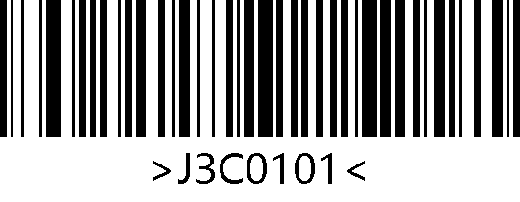
* Enable Codabar
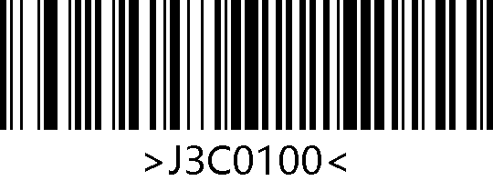
Disable Codabar

Set Length for Codabar
Scan the following setting barcodes to set the minimum length for CodaBar.

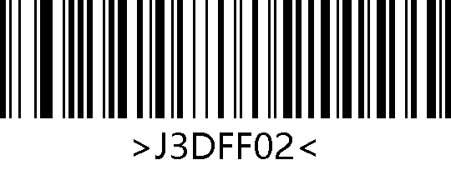
Set the Minimum Length to 2
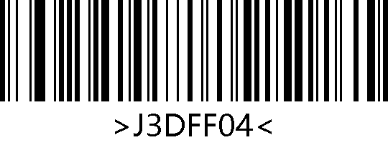
*Set the Minimum Length to 4

CodaBar Check Digit Verification (Mod-16)
Codebar barcode data does not require the inclusion of check digit. If there is, it must be the last byte of the data. The check digit value is calculated from all data except for the check digit, used to verify the integrity of the data.
- If set to "Disable Codabar Verification", the scanner will transmit all barcode data normally.
- Set to "Do Not Transmit Check Digit after Verification", the scanner will verify according to the last digit of the barcode data. If the verification passes, the normal data except for the last check digit will be transmitted. If the verification fails, the barcode content will not be sent.
- If set to "Transmit Check Digit after Verification", the scanner will verify according to the last digit of the barcode data. If the verification passes, the check digit will be transmitted together as the last digit of normal data. If the verification fails, the barcode content will not be sent.

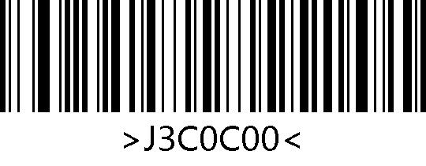
*Disable Codabar Verification
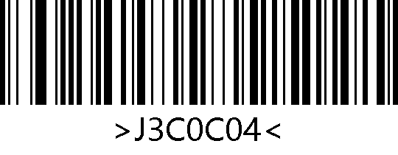
Do Not Transmit Check Digit after Verification
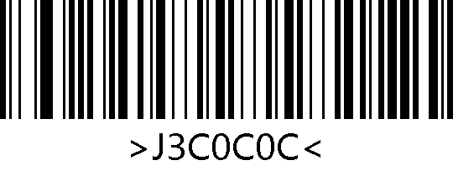
Transmit Check Digit after Verification

When set to "Do Not Transmit Check Digit after Verification", if the data length that minus 1 byte of check digit is less than the minimum length limit, the barcode reading will fail.
For example, in the current scanner settings, if the minimum length for Codabar is 4 bytes, if do not transmit check digit, reading a Codabar with a total length of 4 bytes will fail！

CodaBar Transmit Start/Stop Character
There is one byte data before and after the Codabar barcode data as the start character and the stop character. The start character and the stop character are one of the four characters "A", "B", "C", and "D". Users can set whether to transmit the start character and stop character together with the barcode data after good read.
Scan the following setting barcodes to set the start and stop characters sending of CodaBar.

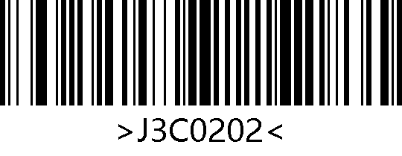
Transmit Start/Stop Character
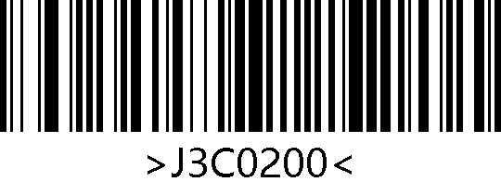
*Do Not Transmit Start/Stop Character

Interleaved 2 of 5

Enable/Disable Interleaved 2 of 5
Scan the following setting barcodes to enable/disable Interleaved 2 of 5.

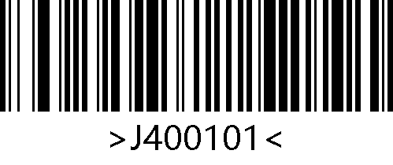
Enable Interleaved 2 of 5
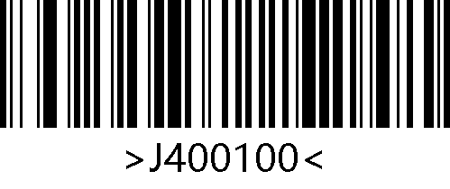
*Disable Interleaved 2 of 5

Set Length for Interleaved 2 of 5
Scan the following setting barcodes to set the minimum length for Interleaved 2 of 5.

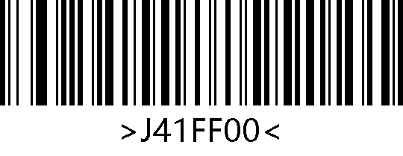
Set the Minimum Length to 0
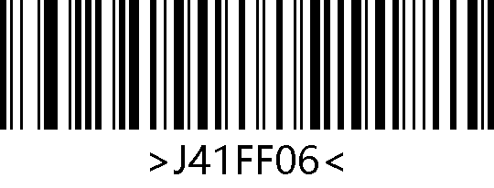
*Set the Minimum Length to 6

Interleaved 2 of 5 Check Digit Verification (Mod-10)
Interleaved 2 of 5 barcode data does not require the inclusion of check digit. If there is, it must be the last byte of the data. The check digit value is calculated from all data except for the check digit, used to verify the integrity of the data.
- If set to "Disable Interleaved 2 of 5 Verification", the scanner will transmit all barcode data normally.
- Set to "Do Not Transmit Check Digit after Verification", the scanner will verify according to the last digit of the barcode data. If the verification passes, the normal data except for the last check digit will be transmitted. If the verification fails, the barcode content will not be sent.
- If set to "Transmit Check Digit after Verification", the scanner will verify according to the last digit of the barcode data. If the verification passes, the check digit will be transmitted together as the last digit of normal data. If the verification fails, the barcode content will not be sent.
The length of the Interleaved 2 of 5 barcode must be even, incudes check digit.. If the length is odd, a “0” is added before the first digit. The check digit is automatically generated during coding.

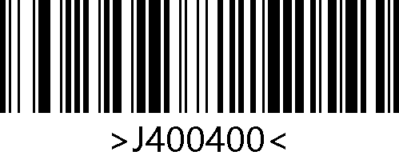
*Disable Interleaved 2 of 5 Verification
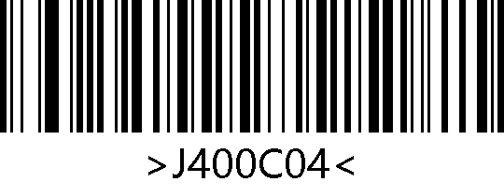
Do Not Transmit Check Digit after Verification
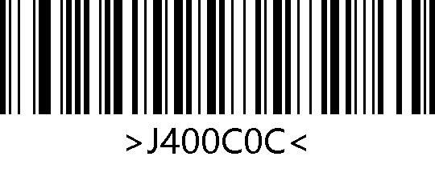
Transmit Check Digit after Verification

When set to "Do Not Transmit Check Digit after Verification", if the data length that minus 1 byte of check digit is less than the minimum length limit, the barcode reading will fail.
For example, in the current scanner settings, the minimum length for Interleaved 2 of 5 is 4 bytes. If do not transmit check digit, reading an Interleaved 2 of 5 with a total length of 4 bytes will fail！

ITF-14
ITF-14 is a specific format of Interleaved 2 of 5, it is 14 digits in length with the last one as its check digit used to verify the integrity of the data.

Enable/Disable ITF-14
Scan the following setting barcodes to enable/disable ITF-14.

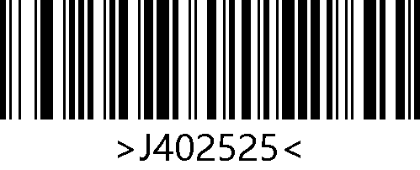
Enable ITF-14
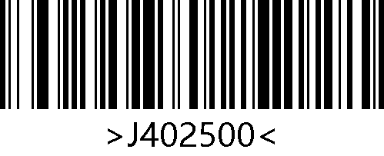
*Disable ITF-14

ITF-6
ITF-6 is similar to ITF-14 as a specific format of Interleaved 2 of 5. It is 6 digits in length with a fixed requirement for verification.

Enable/Disable ITF-6
Scan the following setting barcodes to enable/disable ITF-6.

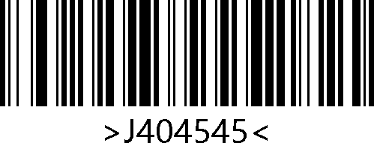
Enable ITF-6
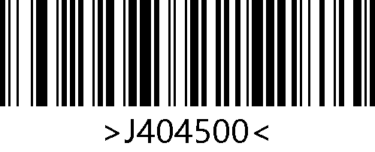
*Disable ITF-6

Industrial 2 of 5

Enable/Disable Industrial 2 of 5
Scan the following setting barcodes to enable/disable Industrial 2 of 5.

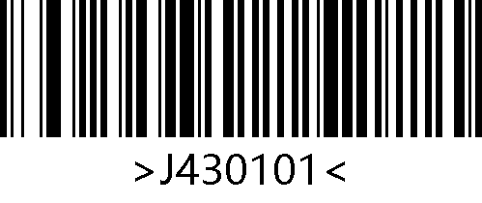
Enable Industrial 2 of 5
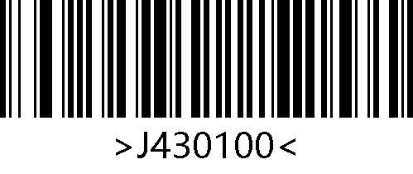
*Disable Industrial 2 of 5

Set Length for Industrial 2 of 5
Scan the following setting barcodes to set the minimum length for Industrial 2 of 5.

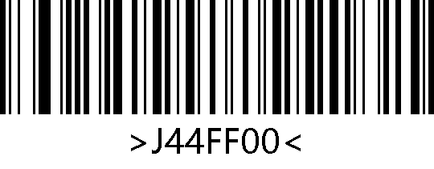
Set the Minimum Length to 0
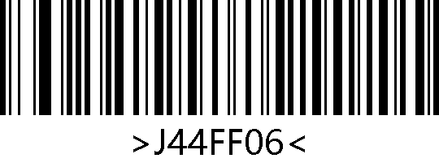
*Set the Minimum Length to 6

Industrial 2 of 5 Check Digit Verification (Mod-10)
The Industrial 25 barcode data does not require the inclusion of check digit. If there is, it must be the last byte of the data. The check digit value is calculated from all data except for the check digit, used to verify the integrity of the data.
- If set to "Disable Industrial 2 of 5 Verification", the scanner will transmit all barcode data normally.
- Set to "Do Not Transmit Check Digit after Verification", the scanner will verify according to the last digit of the barcode data. If the verification passes, the normal data except for the last check digit will be transmitted. If the verification fails, the barcode content will not be sent.
- If set to "Transmit Check Digit after Verification", the scanner will verify according to the last digit of the barcode data. If the verification passes, the check digit will be transmitted together as the last digit of normal data. If the verification fails, the barcode content will not be sent.

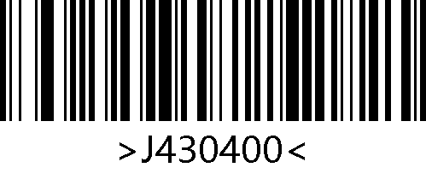
*Disable Industrial 2 of 5 Verification
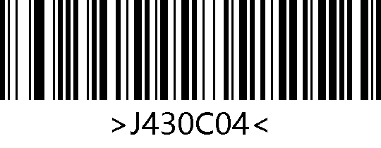
Do Not Transmit Check Digit after Verification
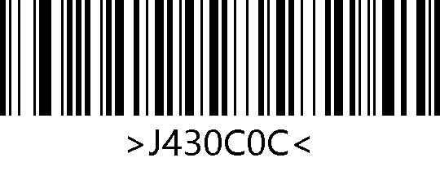
Transmit Check Digit after Verification

When set to "Do Not Transmit Check Digit after Verification", if the data length that minus 1 byte of checksum characters is less than the minimum length limit, the barcode reading will fail.
For example, if the minimum length for Industrial 25 in the current scanner settings is 4 bytes and do not transmit check digit, reading Industrial 25 with a total length of 4 bytes will fail！

Matrix 2 of 5

Enable/Disable Matrix 2 of 5
Scan the following setting barcodes to enable/disable Matrix 2 of 5.

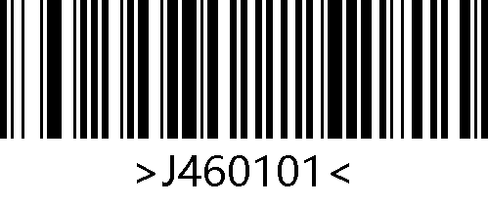
Enable Matrix 2 of 5
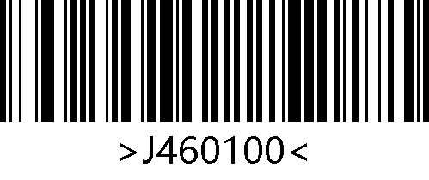
*Disable Matrix 2 of 5

Set Length for Matrix 2 of 5
Scan the following setting barcodes to set the minimum length for Matrix 2 of 5.

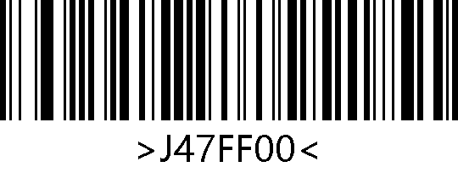
Set the Minimum Length to 0
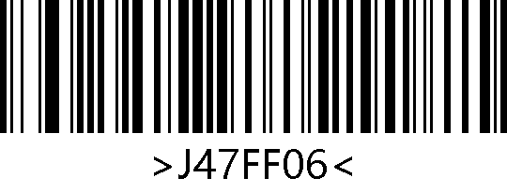
*Set the Minimum Length to 6

Matrix 2 of 5 Check Digit Verification (Mod-10)
Matrix 2 of 5 barcode data does not require the inclusion of check digit. If there is, it must be the last byte of the data. The check digit value is calculated from all data except for the check digit, used to verify the integrity of the data.
- If set to "Disable Matrix 25 Verification", the scanner will transmit all barcode data normally.
- Set to "Do Not Transmit Check Digit after Verification", the scanner will verify according to the last digit of the barcode data. If the verification passes, the normal data except for the last check digit will be transmitted. If the verification fails, the barcode content will not be sent.
- If set to "Transmit Check Digit after Verification", the scanner will verify according to the last digit of the barcode data. If the verification passes, the check digit will be transmitted together as the last digit of normal data. If the verification fails, the barcode content will not be sent.

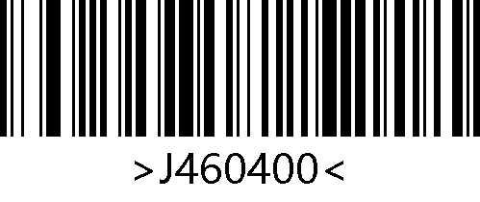
*Disable Matrix 25 Verification
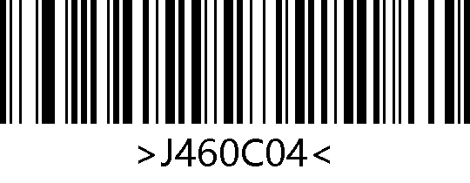
Do Not Transmit Check Digit after Verification
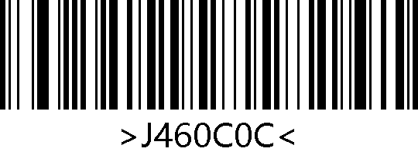
Transmit Check Digit after Verification

When set to "Do Not Transmit Check Digit after Verification", if the data length that minus 1 byte of check digit is less than the minimum length limit, the barcode reading will fail.
For example, if the minimum length for Matrix 2 of 5 in the current scanner settings is 4 bytes and do not transmit check digit, reading Matrix 2 of 5 with a total length of 4 bytes will fail！

Code11

Enable/Disable Code11
Scan the following setting barcodes to enable/disable Code11.

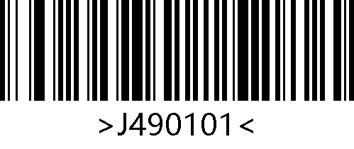
Enable Code 11
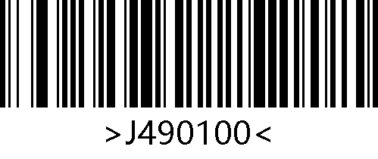
*Disable Code 11

Set Length for Code 11
Scan the following setting barcodes to set the minimum length for Code11.

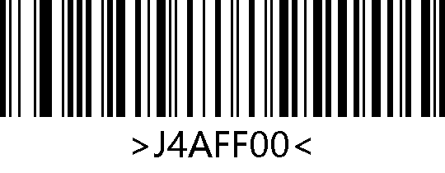
Set the Minimum Length to 0
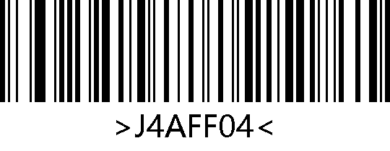
*Set the Minimum Length to 4

Code11 Check Digit Verification
Code 11 barcode data does not require the inclusion of check digit. If there is, it can be the last 1 or 2 bytes of the data. The check digit value is calculated from all data except for the check digit, used to verify the integrity of the data.
Therefore, if select "Disable Code11 Verification", the scanner will transmit all barcode data normally.

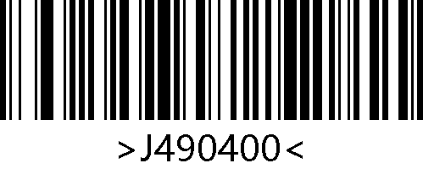
*Disable Code11 Verification
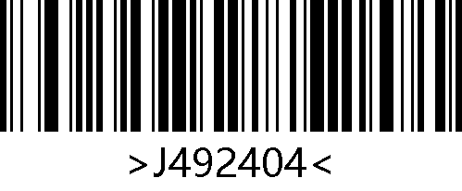
Code11 One Check Digit
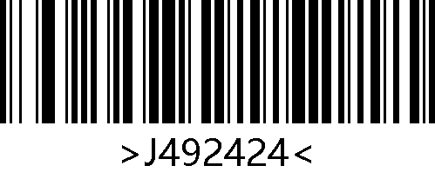
Code11 Two Check Digits

Code11 Transmit Check Digit
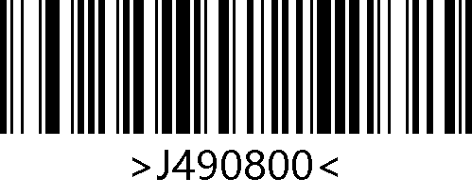
Do Not Transmit Check Digit
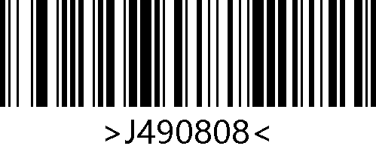
*Transmit Check Digit

MSI-Plessey

Enable/Disable MSI-Plessey
Scan the following setting barcodes to enable/disable MSI Plessey.

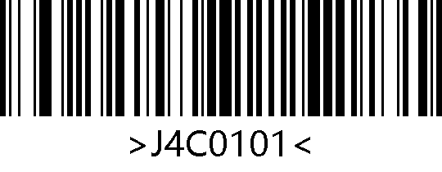
Enable MSI-Plessey
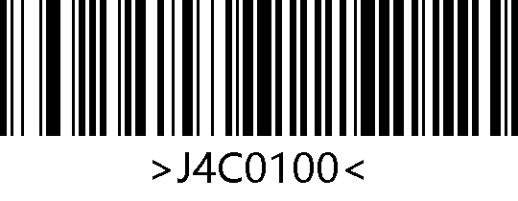
*Disable MSI-Plessey

Set Length for MSI-Plessey
Scan the following setting barcodes to set the minimum length for MSI.

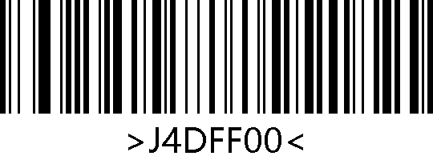
*Set the Minimum Length to 0
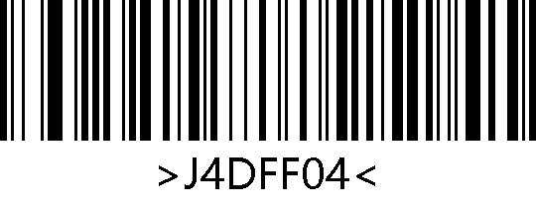
Set the Minimum Length to 4

MSI-Plessey Check Digit Verification
MSI Plessey barcode data does not require the inclusion of check digit. If there is, it is the last 1 or 2 characters of the data. The check digit value is calculated from all data except for the check digit, used to verify the integrity of the data.
If select "Disable MSI Verification", the scanner will transmit all barcode data normally.

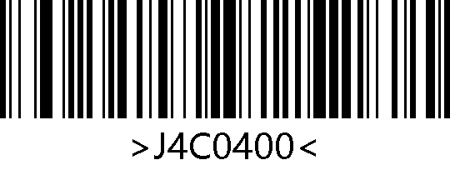
Disable MSI Verification
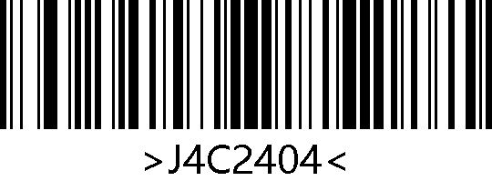
*MSI One Check Digit
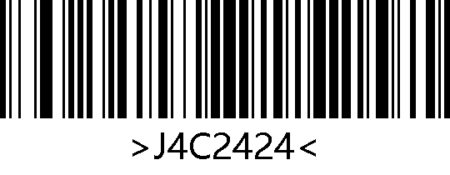
MSI Two Check Digits

MSI-Plessey Transmit Check Digit
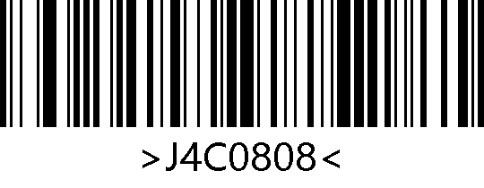
*Transmit Check Digit
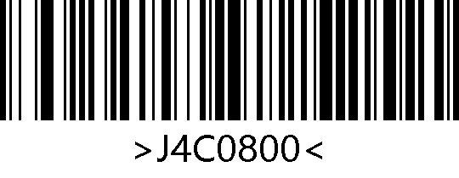
Do Not Transmit Check Digit

When verification is enabled and set to "Do Not Transmit Check Digit", if the data length that minus 2 bytes of check digit is less than the minimum length limit, the reading will fail.
For example, in the current scanner settings, the minimum length for MSI Plessey is 4 bytes, and if do not transmit check digit, reading MSI Plessey with a total length of 4 bytes will fail！

GS1-Databar (RSS)

Enable/Disable RSS-14
Scan the following setting barcodes to enable/disable RSS-14.

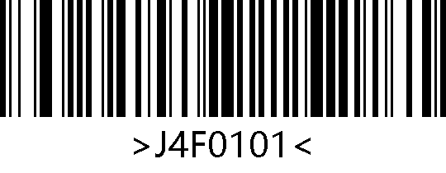
Enable RSS-14
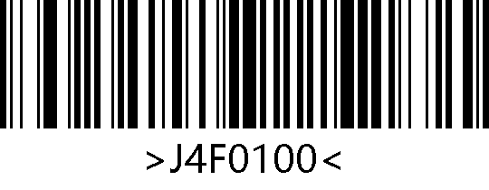
*Disable RSS-14
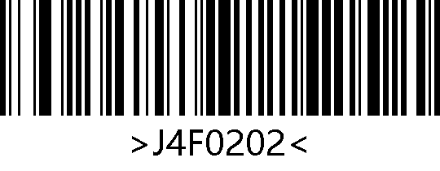
*Transmit Application Identifier “01”
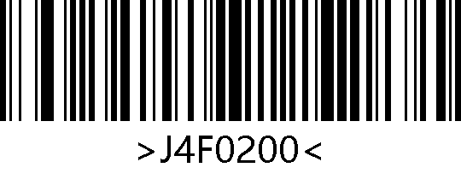
Do Not Transmit Application Identifier “01”

Enable/Disable RSS-Limited
Scan the following setting barcodes to enable/disable RSS-Limited.

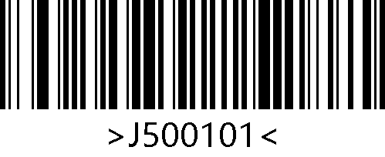
Enable RSS-Limited
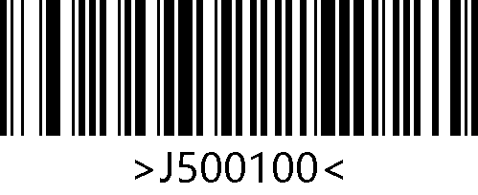
*Disable RSS-Limited
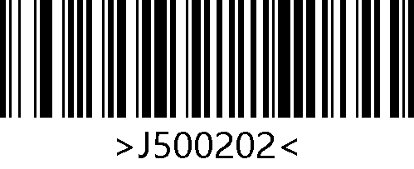
*Transmit Application Identifier“01”
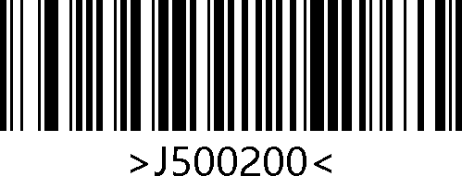
Do Not Transmit Application Identifier “01”

Enable/Disable RSS-Expanded
Scan the following setting barcodes to enable/disable RSS-Expanded.

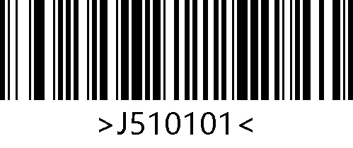
Enable RSS-Expanded
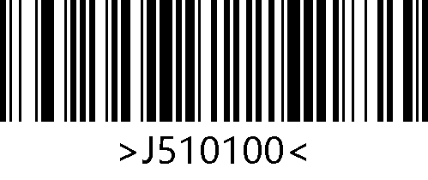
*Disable RSS-Expanded
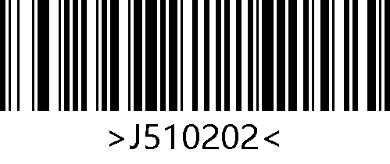
*Transmit Application Identifier “01”

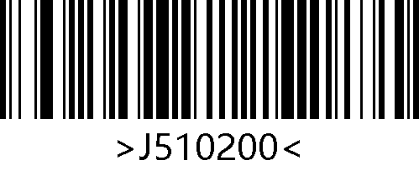
Do Not Transmit Application Identifier “01”

Set Length for RSS
Scan the following setting barcodes to set the minimum length for RSS.

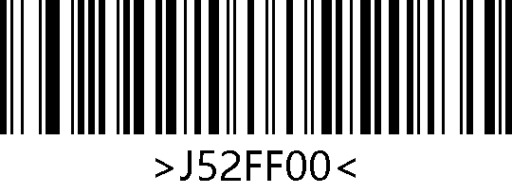
Set the Minimum Length to 0
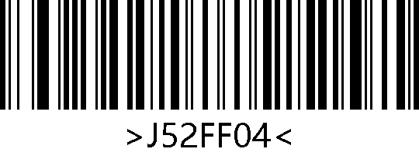
*Set the Minimum Length to 4

Micro QR Code

Enable/Disable Micro QR Code
Scan the following setting barcodes to enable or disable Micro QR code.

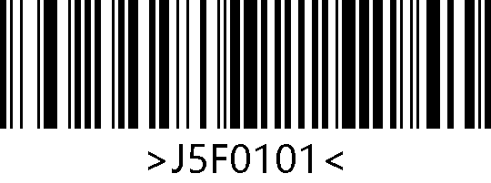
Enable Micro QR Code
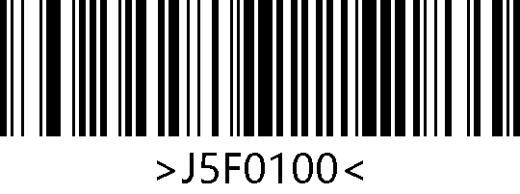
*Disable Micro QR Code

QR Code

Enable/Disable QR Code
Scan the following setting barcodes to enable/disable QR code.

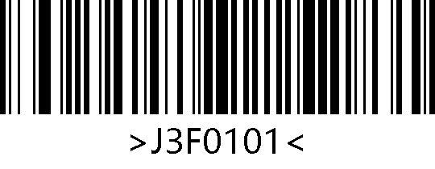
*Enable QR Code
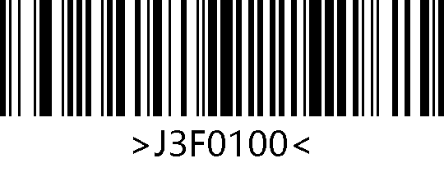
Disable QR Code

Data Matrix

Enable/Disable DM
Scan the following setting barcodes to enable/disable DM.

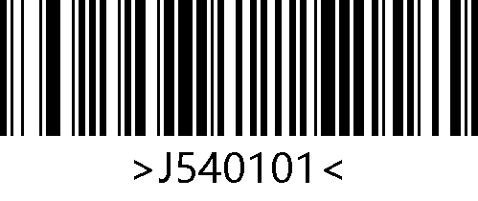
*Enable DM
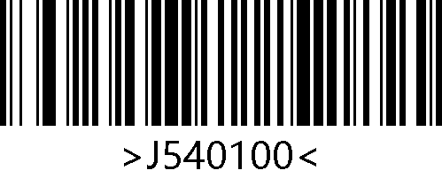
Disable DM

PDF417

Enable/Disable PDF417
Scan the following setting barcodes to enable/disable PDF417.

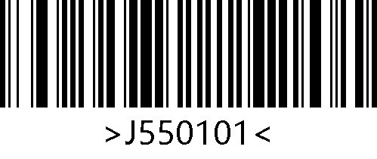
*Enable PDF417
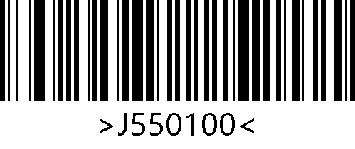
Disable PDF417

Micro PDF417

Enable/Disable Micro PDF417
Scan the following setting barcodes to enable/disable Micro PDF417.

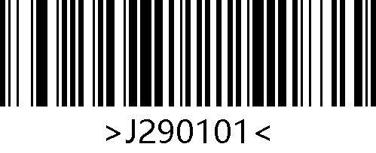
Enable Micro PDF417
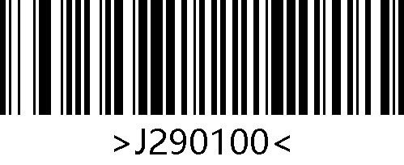
*Disable Micro PDF417

Aztec Code

Enable/Disable Aztec Code
Scan the following setting barcodes to enable/disable Aztec Code.

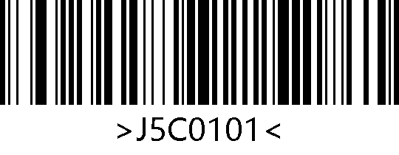
Enable Aztec
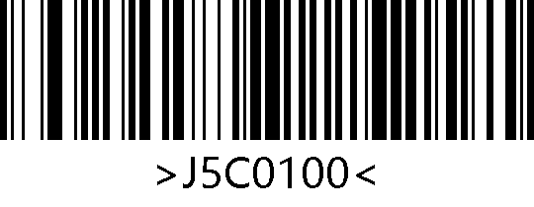
*Disable Aztec

Maxi Code

Enable/Disable Maxi Code
Scan the following setting barcodes to enable/disable Maxi Code.

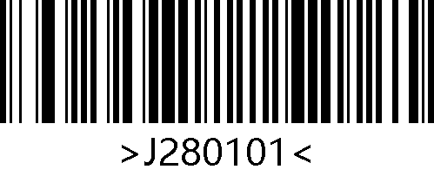
Enable Maxi
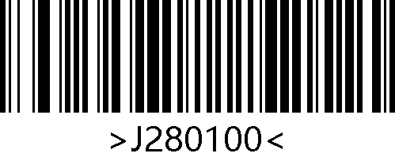
*Disable Maxi

Appendix C：Code ID Table
Table 11-1 Code ID Table
Symbology | Code ID
Aztec | z
Codabar | a
Code39 | b
Code93 | i
Code128 | j
GS1 DataBar(RSS14) | R
GS1 DataBar Expanded | R
Data Matrix | u
EAN-8 | d
EAN-13 | d
Interleaved 2 of 5 | e
Maxi | x
PDF417 | r
QR | Q
UPC-A | c
UPC-E | c
Micro QR | Q
MSI Plessey | m
Industrial 2 of 5 | I
Matrix 2 of 5 | v
Code 11 | H
ISSN | g
ISBN | B
GS1 DataBar Limited | R
Micro PDF417 | s
Code32 | b

Appendix D：ASCII Table
Table 12-1 ASCII Table
Hex | Dec | Char
00 | 0 | NUL (Null Char.)
01 | 1 | SOH (Start Of Header)
02 | 2 | STX (Start Of Text)
03 | 3 | ETX (End Of Text)
04 | 4 | EOT (End Of Transmission)
05 | 5 | ENQ (Enquiry)
06 | 6 | ACK (Acknowledgment)
07 | 7 | BEL (Bell)
08 | 8 | BS (Backspace)
09 | 9 | HT (Horizontal Tab)
0a | 10 | LF (Line Feed)
0b | 11 | VT (Vertical Tab)
0c | 12 | FF (Form Feed)
0d | 13 | CR (Carriage Return)
0e | 14 | SO (Shift Out)
0f | 15 | SI (Shift In)
10 | 16 | DLE (Data Link Escape)
11 | 17 | DC1 (XON) (Device Control 1)
12 | 18 | DC2 (Device Control 2)
13 | 19 | DC3 (XOFF) (Device Control 3)
14 | 20 | DC4 (Device Control 4)
15 | 21 | NAK (Negative Acknowledgment)
16 | 22 | SYN (Synchronous Idle)
17 | 23 | ETB (End of Trans. Block)
18 | 24 | CAN (Cancel)
19 | 25 | EM (End Of Medium)
1a | 26 | SUB (Substitute)
1b | 27 | ESC (Escape)
1c | 28 | FS (File Separator)
1d | 29 | GS (Group Separator)
1e | 30 | RS (Request To Send)
1f | 31 | US (Unit Separator)
20 | 32 | SP (Space)
21 | 33 | ! (Exclamation Mark)
22 | 34 | " (Double Quote)
23 | 35 | # (Number Sign)
24 | 36 | $ (Dollar Sign)
25 | 37 | % (Percent)
26 | 38 | & (Ampersand)
27 | 39 | ` (Single Quote)
28 | 40 | ( (Right / Closing Parenthesis)
29 | 41 | ) (Right / Closing Parenthesis)
2a | 42 | * (Asterisk)
2b | 43 | + (Plus)
2c | 44 | , (Comma)
2d | 45 | - (Minus / Dash)
2e | 46 | . (Dot)
2f | 47 | / (Forward Slash)
30 | 48 | 0
31 | 49 | 1
32 | 50 | 2
33 | 51 | 3
34 | 52 | 4
35 | 53 | 5
36 | 54 | 6
37 | 55 | 7
38 | 56 | 8
39 | 57 | 9
3a | 58 | : (Colon)
3b | 59 | ; (Semi-colon)
3c | 60 | < (Less Than)
3d | 61 | = (Equal Sign)
3e | 62 | > (Greater Than)
3f | 63 | ? (Question Mark)
40 | 64 | @ (AT Symbol)
41 | 65 | A
42 | 66 | B
43 | 67 | C
44 | 68 | D
45 | 69 | E
46 | 70 | F
47 | 71 | G
48 | 72 | H
49 | 73 | I
4a | 74 | J
4b | 75 | K
4c | 76 | L
4d | 77 | M
4e | 78 | N
4f | 79 | O
50 | 80 | P
51 | 81 | Q
52 | 82 | R
53 | 83 | S
54 | 84 | T
55 | 85 | U
56 | 86 | V
57 | 87 | W
58 | 88 | X
59 | 89 | Y
5a | 90 | Z
5b | 91 | [ (Left / Opening Bracket)
5c | 92 | \ (Back Slash)
5d | 93 | ] (Right / Closing Bracket)
5e | 94 | ^ (Caret / Circumflex)
5f | 95 | _ (Underscore)
60 | 96 | ' (Grave Accent)
61 | 97 | a
62 | 98 | b
63 | 99 | c
64 | 100 | d
65 | 101 | e
66 | 102 | f
67 | 103 | g
68 | 104 | h
69 | 105 | i
6a | 106 | j
6b | 107 | k
6c | 108 | l
6d | 109 | m
6e | 110 | n
6f | 111 | o
70 | 112 | p
71 | 113 | q
72 | 114 | r
73 | 115 | s
74 | 116 | t
75 | 117 | u
76 | 118 | v
77 | 119 | w
78 | 120 | x
79 | 121 | y
7a | 122 | z
7b | 123 | { (Left/ Opening Brace)
7c | 124 | | (Vertical Bar)
7d | 125 | } (Right/Closing Brace)
7e | 126 | ~ (Tilde)
7f | 127 | DEL (Delete)

Appendix E：Digit Barcodes
0 ~ 9

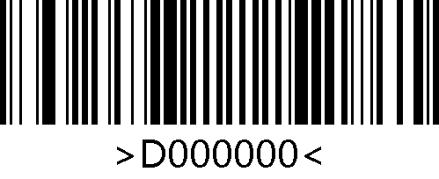
0
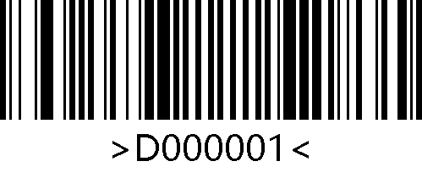
1
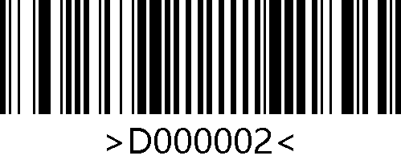
2
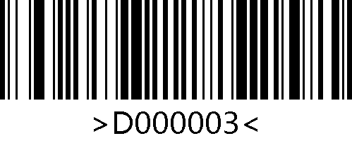
3
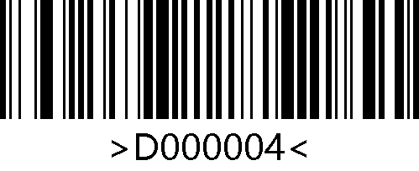
4
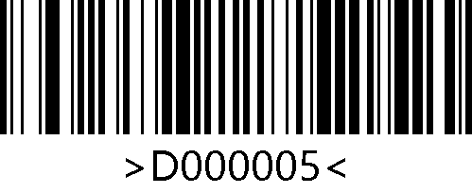
5
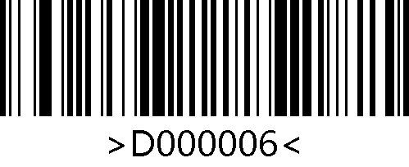
6
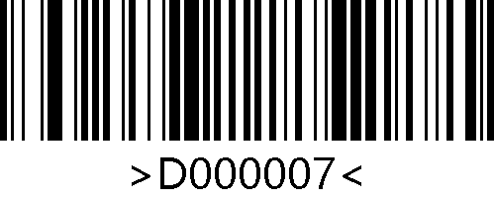
7

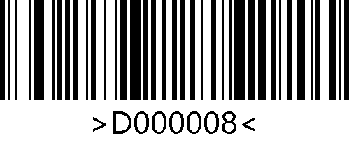
8
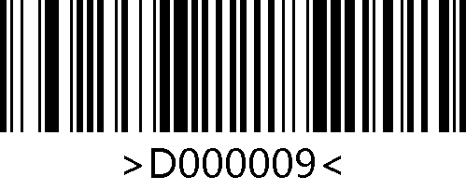
9

A – F

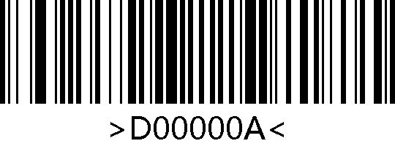
A
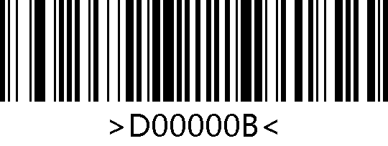
B

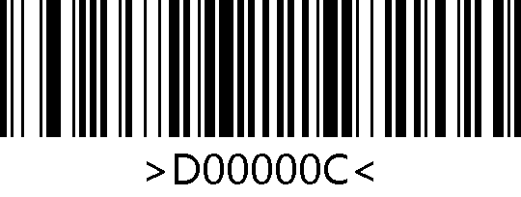
C
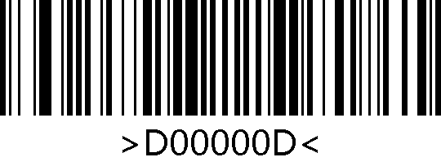
D
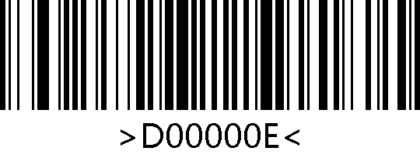
E
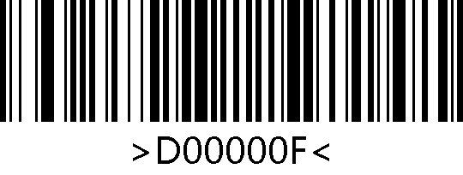
F

Appendix F：Save/Cancel Barcodes
After scanning the digit barcodes, you need to scan the "Save" barcode to save the data. If you scan the wrong digits, you can cancel the wrong scanned digits.
For example, after scanning a certain setting barcode and digit barcodes "A", "B", "C", "D", you can:
"Delete the Last Digit": The last digit "D" will be deleted.
"Delete All Digits": All digits "ABCD" will be deleted.
"Cancel": All digits "ABCD" will be deleted and the configuration will be cancelled.

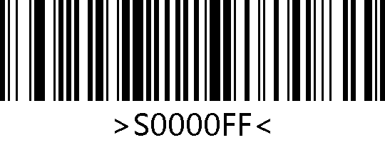
Save
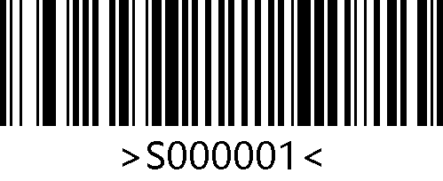
Delete the Last Digit
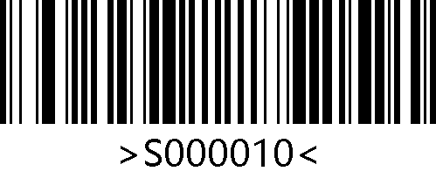
Delete All Digits
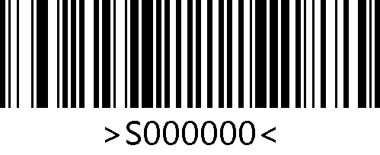
Cancel

